

Client Asset Tracker -AMEX

# Contents

|  |  |
| --- | --- |
| **Introduction**  Overview  Purpose | 1  1 |
| **Application Flow**  Registration/Login/PMO Approval  Role Based Authorizations  EPL Data  Data Feed  Home Page  Master History  Reports  Notifications | 3  8  12  13  18  23  25  31 |



INTRODUCTION

# Introduction

## Overview

Client Asset tracker is an application for AMEX PMO TEAM. Aim of this application is to simplify the daily tasks of PMO’s. It’s an application that tracks the Amex asset provided by Amex to the employees from the time of onboarding to return of the assets that are tagged under Amex. This application converts most of the manual work (around 80%) to digitalized version, by which we have achieved more efficiency, reduction of time consumption and manpower.

## Purpose

There are two main purpose of this application one is to take input data feed in the form of excel file from user end and automatically map them to respective nodal points in application database which makes the data accessibility easy and efficient. And according to requirements of the users they can access the filtered data in the form of reports both in excel and pdf formats.

And the second one is tracking of assets in every stage i.e., from assets allocation during the time of onboarding and till return of the assets at time of project release. And each stage needs to be provided with authorizations and valid receipts from the employee end for proper tracking of the asset.

Application Flow

# Application Flow and Instructions

## Screenshots of Application Flow and instructions:

**Registration / Login / PMO approval: -**

**STEP1: -**

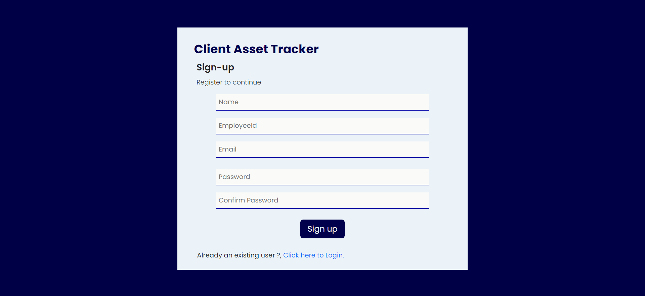

* This is the step one where the user must register for getting access to CAT application.
* To register this we require the Name, Employee Id, Email, Password, confirm password.
* Passwords contain below conditions.
  + Password Must have Minimum 8 characters.
  + Password Must have a special character.
  + Password Must have a number.
  + Password Must have a lower-case letter.
  + Password Must have an upper-case letter.
  + For example: Name@1234.

**STEP 2: -**

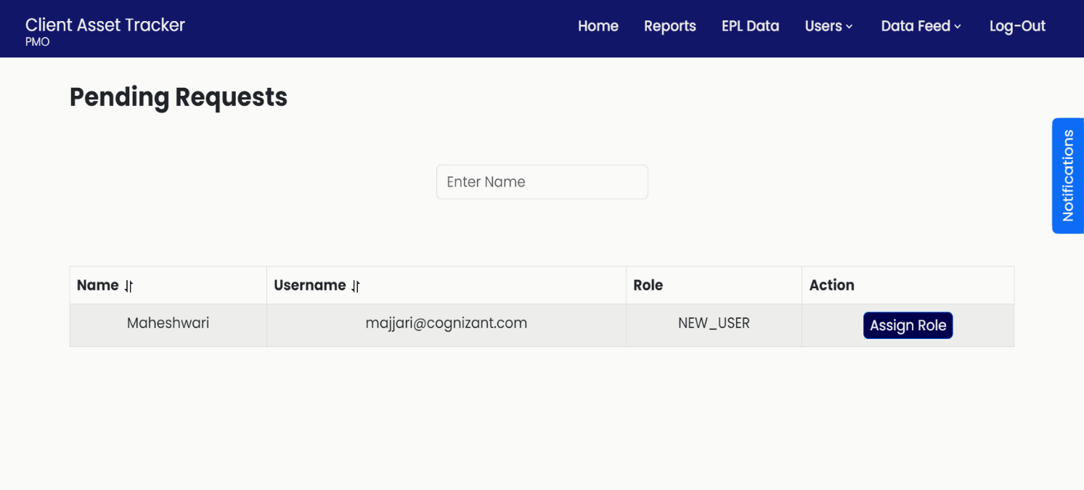

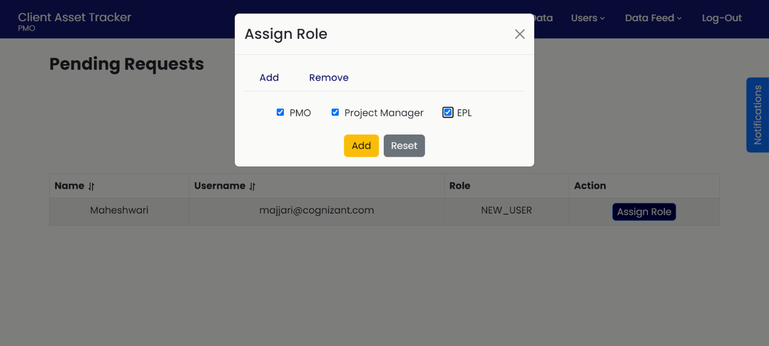

* After registration, the user details will be displayed to PMO for approval and role assignments.
* PMO can also add multiple roles for one user according to their respective role.

**NOTE**: - CAT has role-based authentication application so PMO must be careful while assigning roles for new users during approvals.

**STEP 3: -**

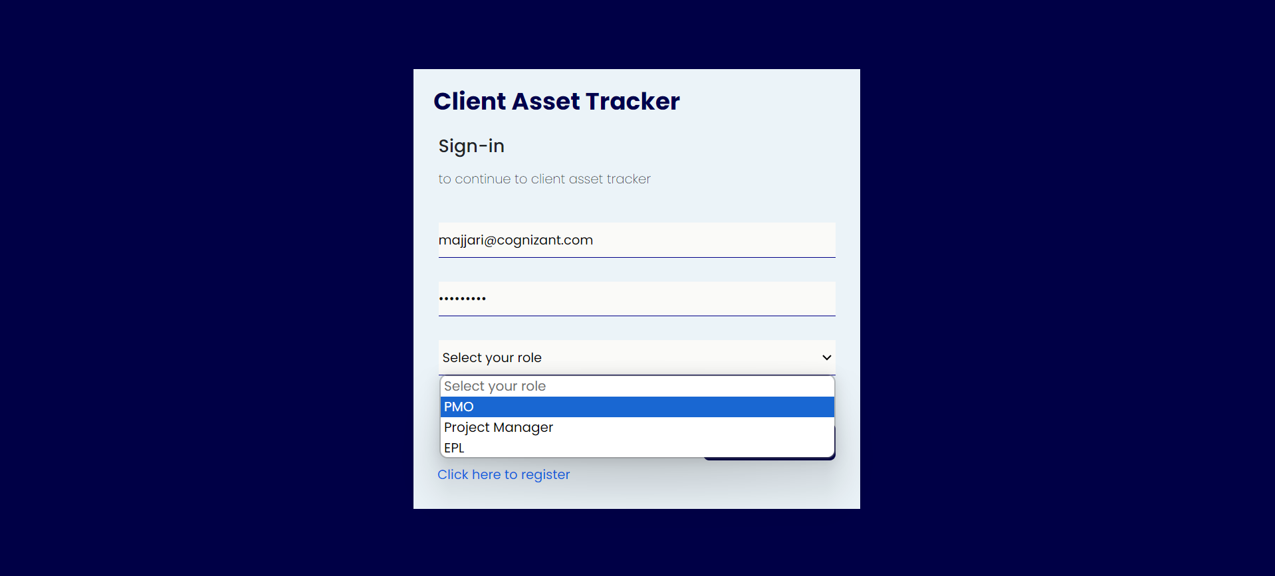

* After PMO approval, user can login using their credentials and approved role.
* **Exceptions and Validations: -**

1. If user tries to login without registration or PMO approval, an error will pop up as illustrated below.

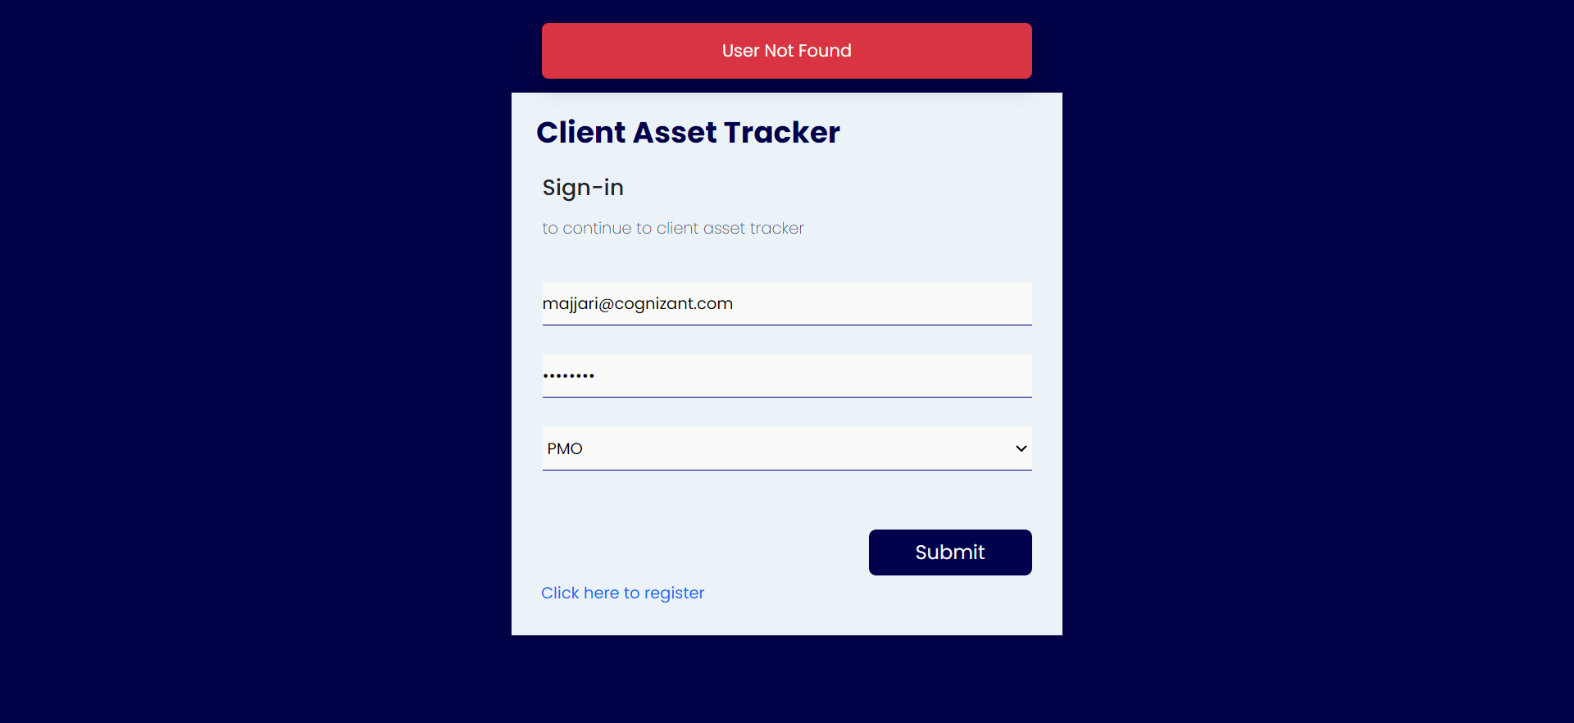

1. During registration we must make sure that the password is provided according to the data validation checks ask given below, to ensure data security.

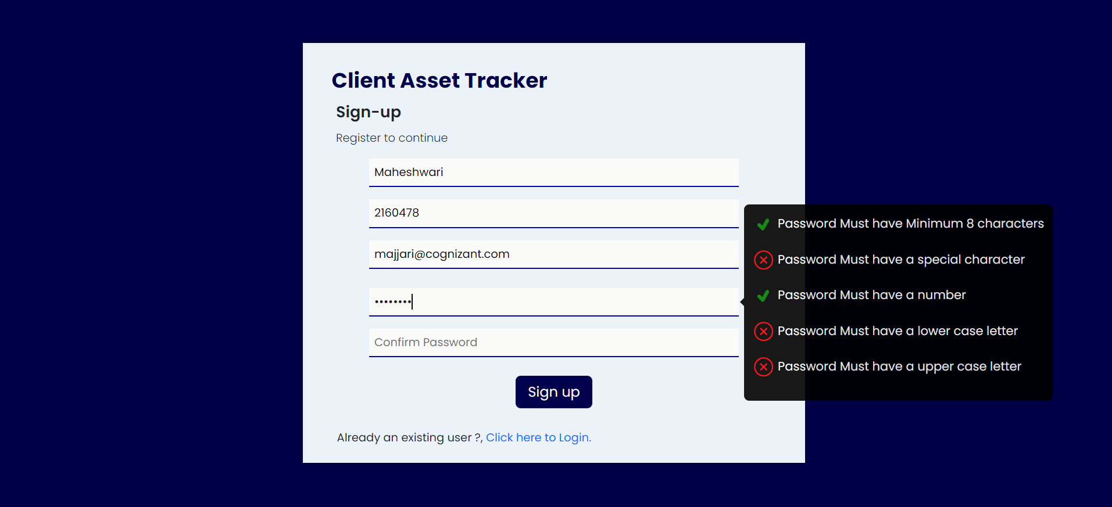

1. A PMO can add as well as remove the user or their role from the application.

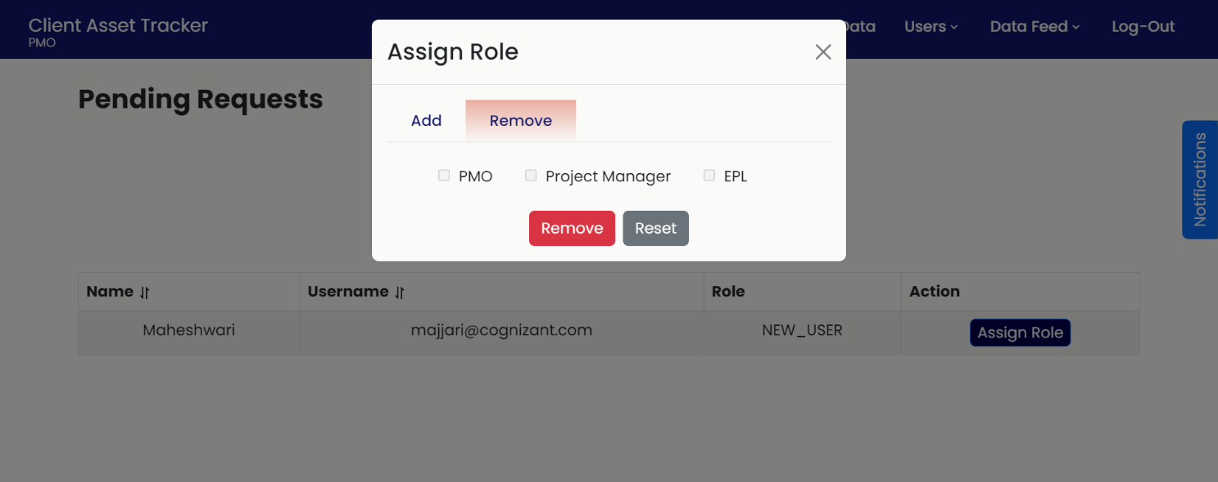

1. List of all the users and their details will be displayed for PMO from where they can manage the accessibility of the application using role-based authentication.

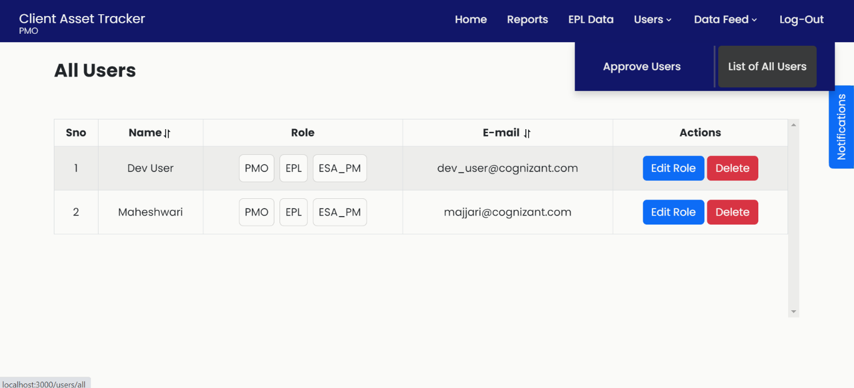

**NOTE** :- According to the assigned role the Headers features will be changed according to their roles.

**ROLE BASED AUTHORIZATIONS: -**

* According to the role granted to the user, the access and the associated data available to the user varies.
* Features of the Application such as Reports, and Data Feed Updating is available for access under all roles.
* In case a user has multiple roles assigned to them, they can switch between their roles within the home page. The feature is located on the top left of the page.

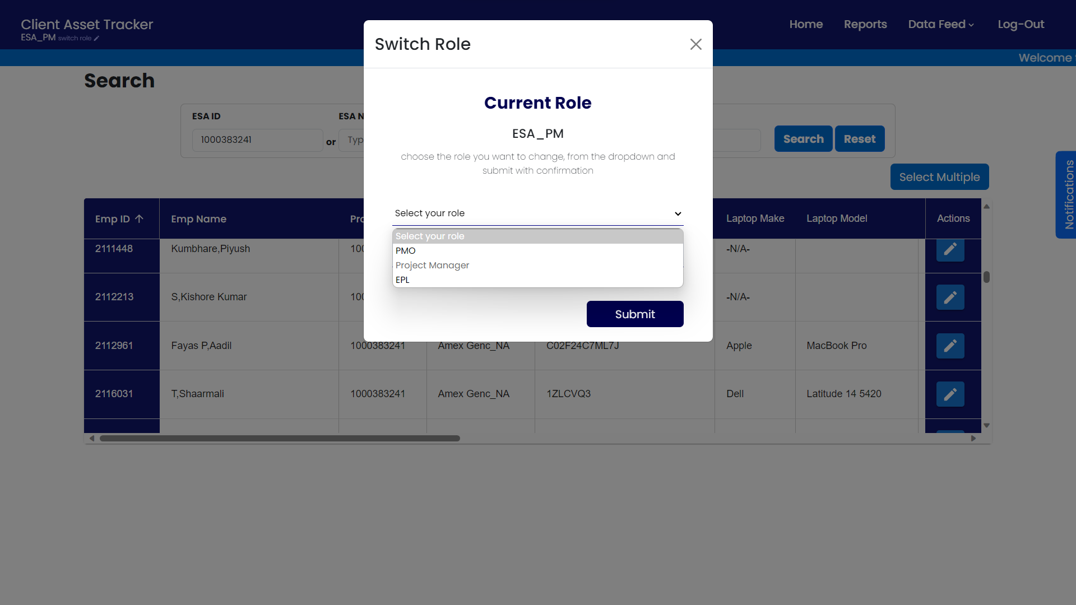

* Within this popup, the user can select the role they want to switch to and enter the login details for the role.

**PMO:**

* They have the most features available amongst the roles and have control over granting roles to other users as well, akin to an Administrator level account.
* They have access to modify and update the asset tracking details of all ESA Project ID’s and Associates tagged to them.
* They have permission to add or remove any EPL’s.
* They have the permission to assign and change a user’s role.

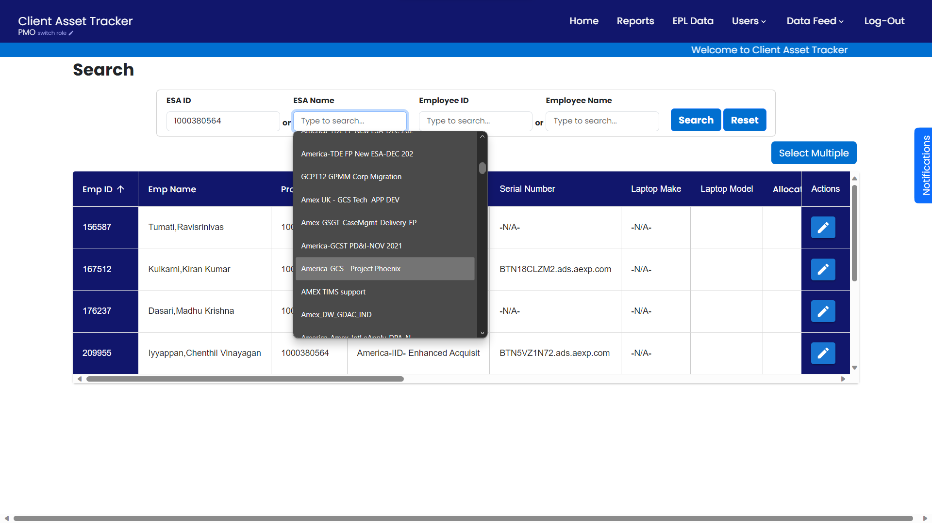

**EPL:**

* An EPL, when logged in, they can access and modify asset tracking details of any associates, for which the user is tagged as the EPL or ESA PM for that account.

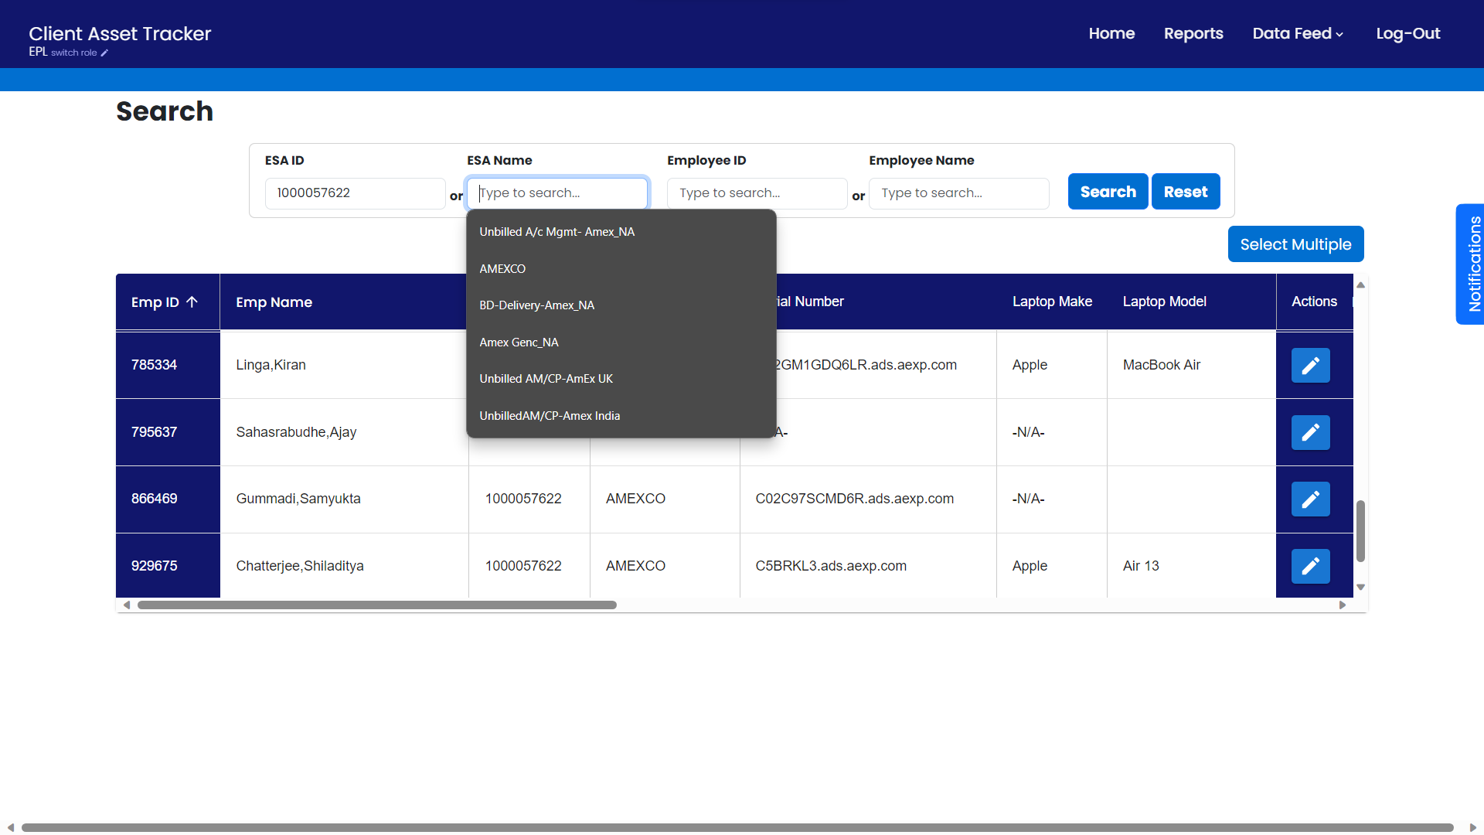

* Note: In the above screenshot, The user only has access to the projects on which they are tagged as the EPL and ESA PM

**ESA PM:**

* An ESA PM, when logged in, they can access and modify asset tracking details of any associates, for which the user is tagged as the ESA PM for that account.

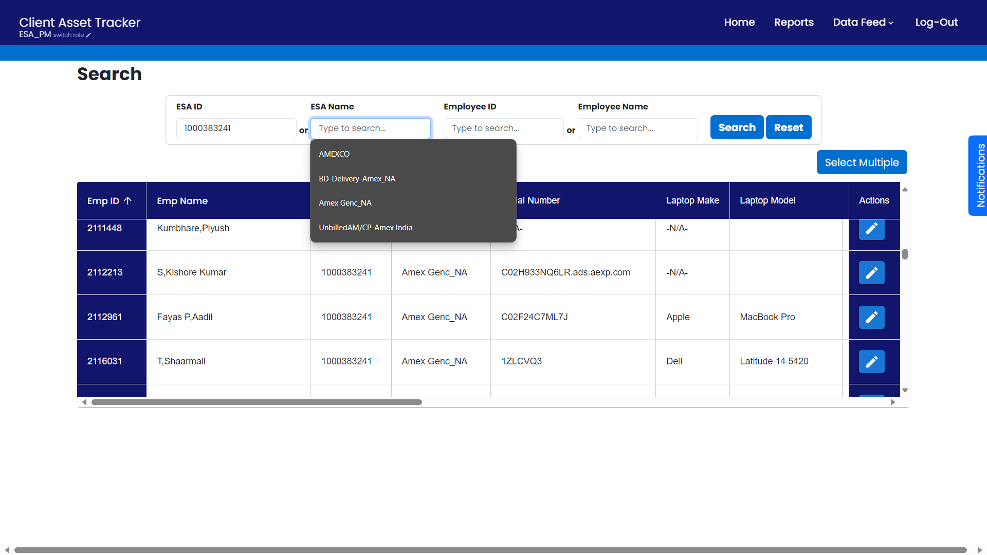

* Note: In the above screenshot, The user only has access to the projects on which they are tagged as the ESA PM.

**EPL DATA:**

**STEP1: -**

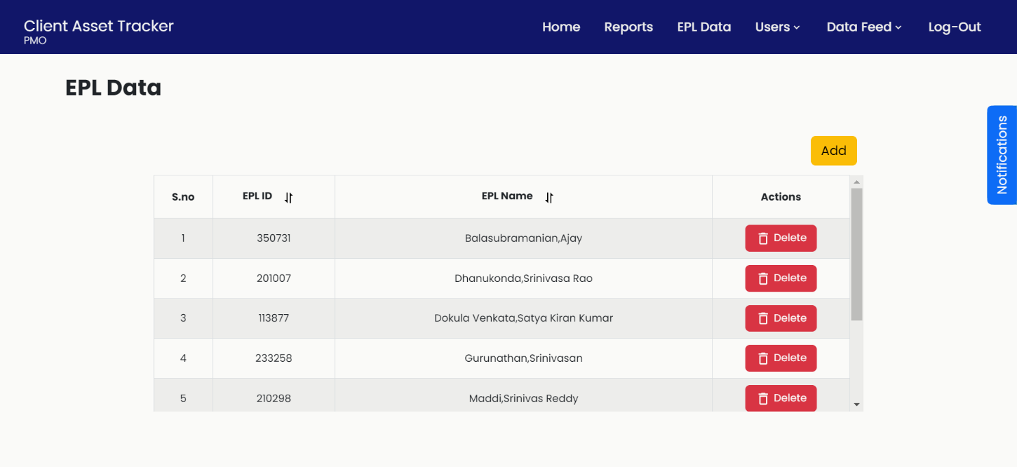

**STEP2: -**

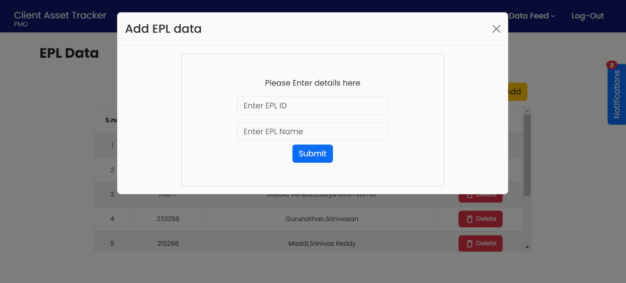

* PMO should add EPL data before performing any actions like Data feed or editing the data from home page, so that all the EPL’s are mapped correctly.
* PMO Should add:
  + EPL ID
  + EPL Name

**Data Feed:**

* The Data Feed page is provided to update and enter associate records into the application for asset tracking features by uploading an Excel file.
* Each associate record in the file must adhere to the below data constraints to pass data validation.

|  |  |
| --- | --- |
| Assignment ID | only numerical values |
| Associate ID | only numerical values |
| Associate Name | only Alphabetical values and comma (,) allowed |
| Grade | only capital alphabets and '/' allowed |
| Amex Contractor ID | only Alpha- numerical values |
| Amex Email ID | only Alpha- numerical values, dot(.), hyphen (-), underscore (_) and should end with @aexp.com |
| City | only alphabets and hyphen (-) allowed |
| Country | only alphabetical values allowed |
| Billability Status | only 'Y' or 'N' allowed |
| Business Unit | only alphabets, dot(.) and hyphen (-) allowed |
| Service Line | only alphabets, ampersand (&) and hyphen (-) is allowed |
| Project ID | only numerical values |
| Project name | All alpha-numerical values and special characters allowed |
| Project Manager ID | only numerical values |
| Project Manager Name | Only Alphabetical values and comma (,) allowed |
| Project start date | dd/mm/yyyy or dd-mm-yy |
| Project end date | dd/mm/yyyy or dd-mm-yy |
| Percent Allocation | only numerical values |
| EPL | Only Alphabetical values and comma (,) allowed |
| Cognizant Asset | only alpha |
| Amex Serial Number | only alpha |
| Asset Make | only alphabetical values allowed |
| Asset Model | all alpha |

**STEP1: -**

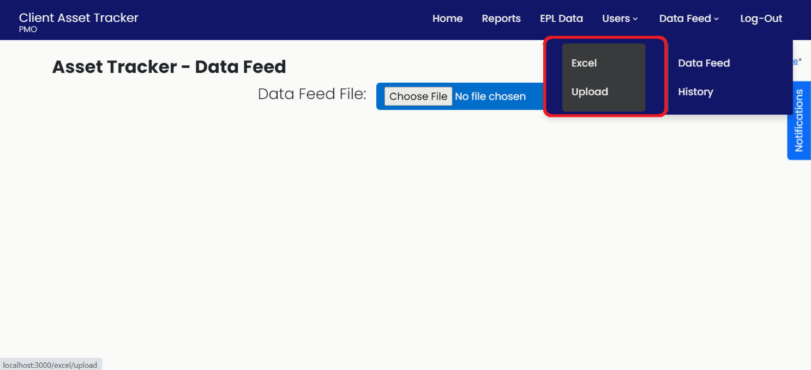

* Data feed can be populated by uploading Excel file through Excel Upload tab as shown above.

**STEP2: -**

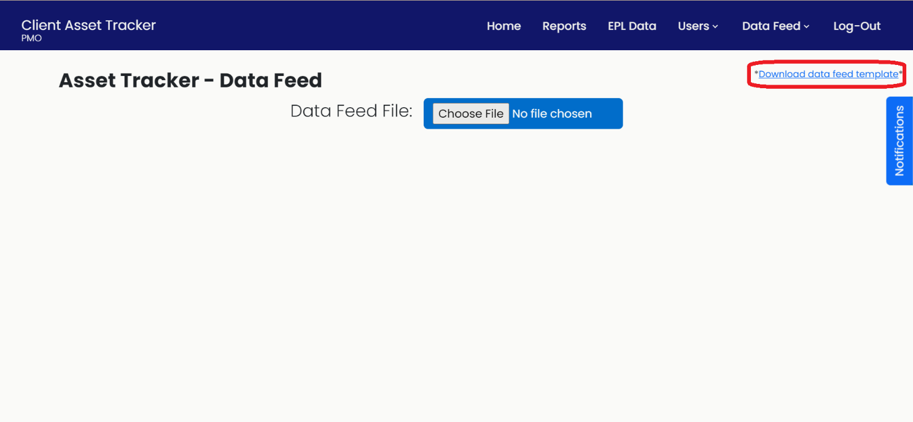

* For Excel file upload user can download the template provided in Data Feed tab as shown above.
* User can directly download the template and edit it and upload the same file.

**STEP 3: -**

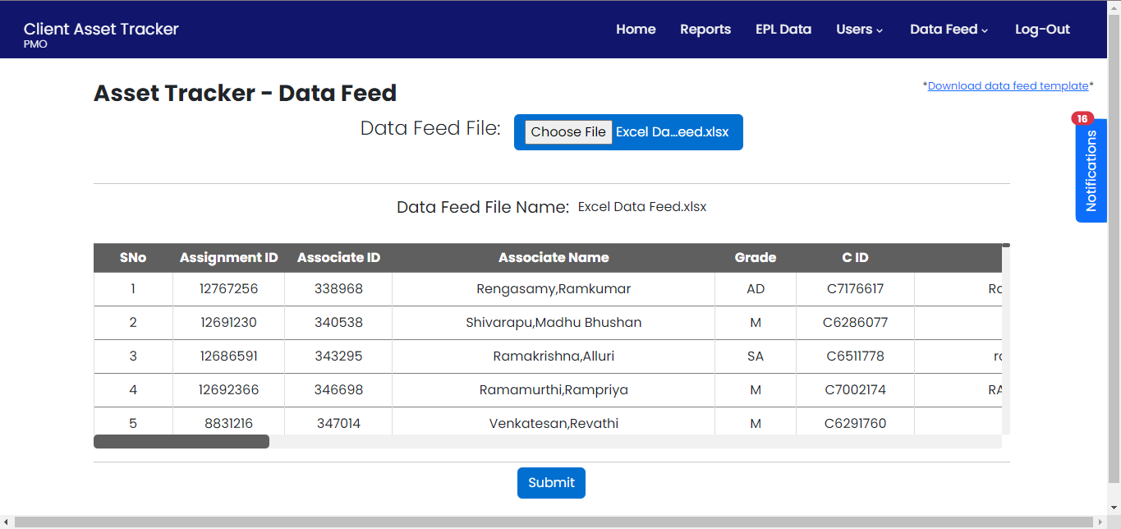

* After user selects proper Excel file user need to click on submit button provided.

**STEP 4: -**

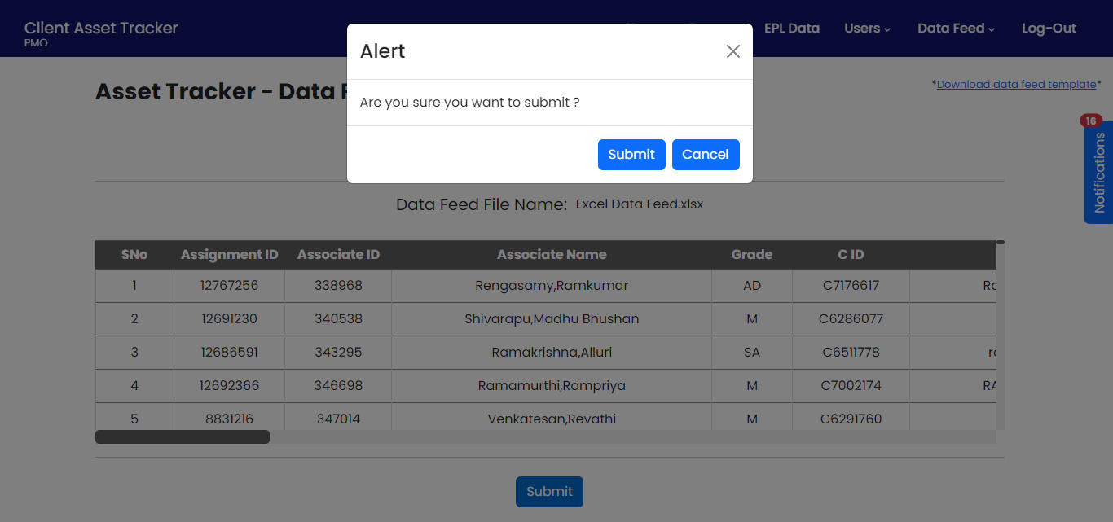

* A pop-up will appear on screen for user confirmation of file to be upload.
* Click on submit.

**STEP 5: -**

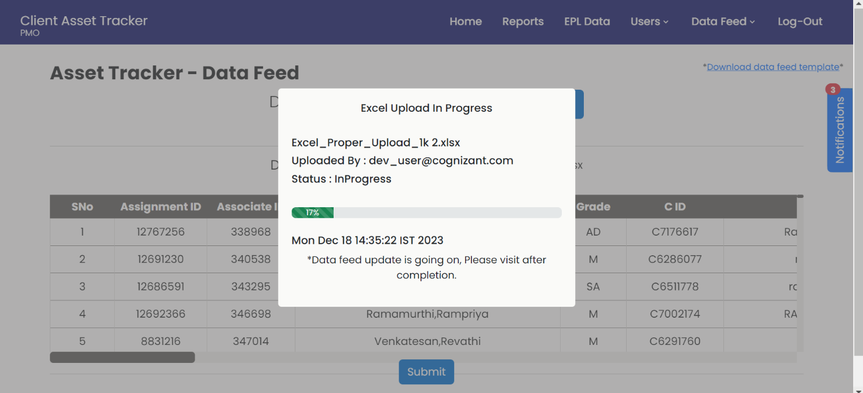

* While file uploading, we can see all the data like:
  + File name
  + Uploaded By
  + Status
  + Time and date of uploading

**STEP 6: -**

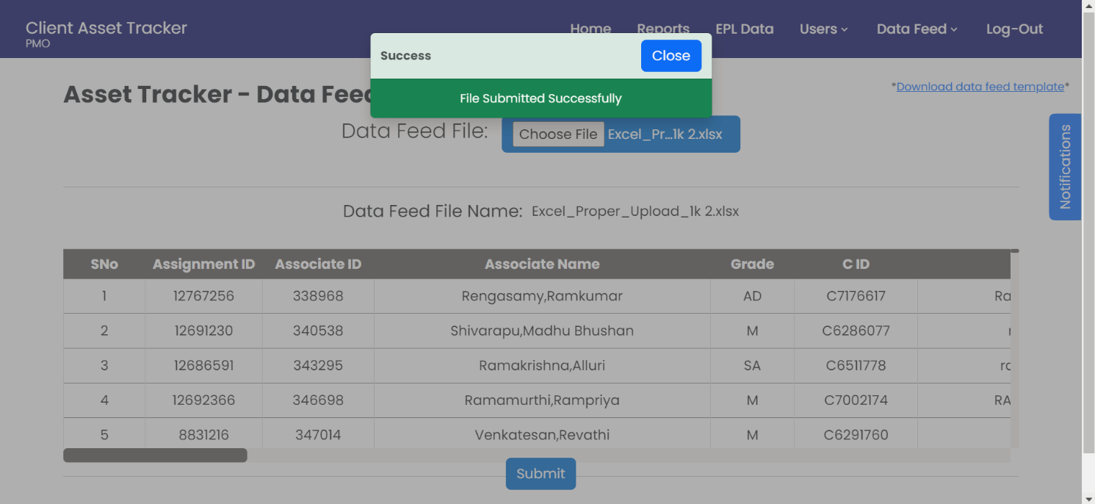

* After completion of uploading a “File Submitted Successfully” message will pop-up.
* Click on Close.

**DATA FEED WITH MISSING FIELDS:**

**STEP 1: -**



* Select the file.

**STEP 2: -**

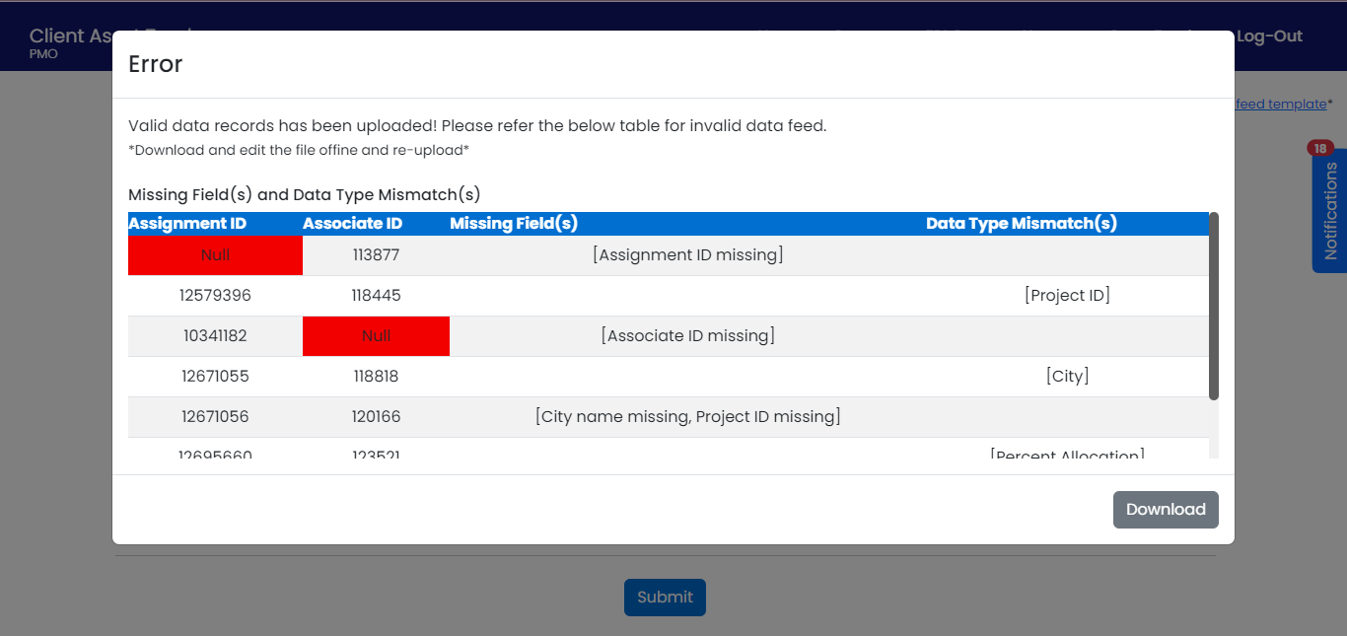

* If any missing fields are present in uploaded excel file, an error message will appear as shown above, stating all the missing fields with their: -
  + Assignment ID
  + Associate ID
  + Missing Fields
  + Data Type of Mismatch
* And we can download this file in the format of Excel and fill those fields appropriately and re-upload the same file.

**HOME PAGE:**

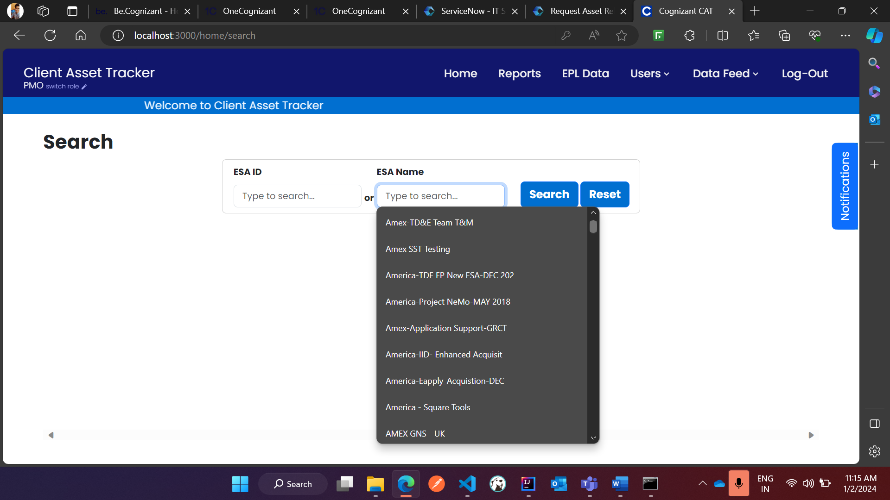

* The home page provides the user with 2 initial fields that are ESA ID and ESA Name. The user can select the blank fields to trigger a dropdown to view the list of ESAs assigned under the user.
* The ESA ID and ESA Name will be Role based, PMO will be having access to all the ESAs under the AMEX account, whereas EPL and ESA PM will be only displayed with the ESAs that they have been assigned with.

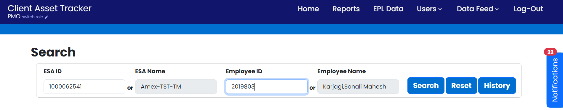

* After we select the ESA, the user can either load all the employees under the assigned ESA, or select a particular employee by selecting from the Employee ID or Employee Name. The employees are then loaded according to the user’s selection and are ready for modification.

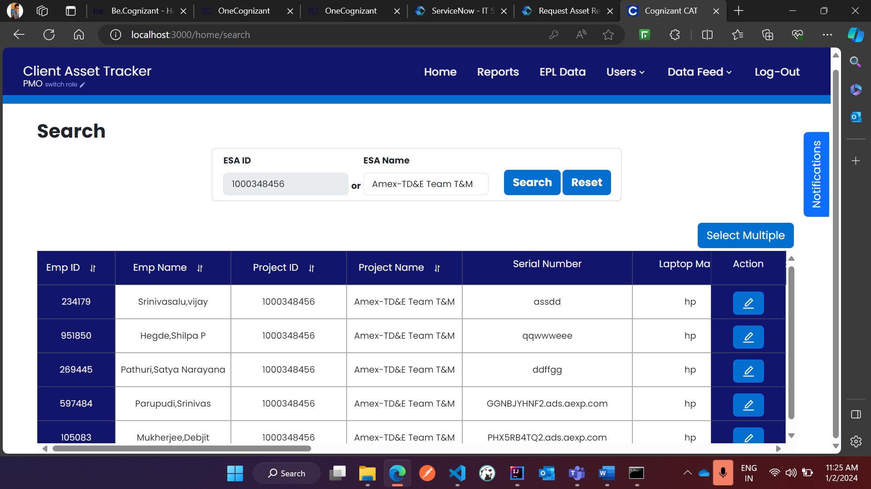

* The following are the fields which are accessible and to be modified by the user:
  + Employee Name (available)
  + Project ID (available)
  + Project Name (available)
  + Serial Number (to be entered if unavailable)
  + Laptop Make (to be entered if unavailable)
  + Laptop Model (to be entered if unavailable)
  + Allocated Date (to be added)
  + Asset Release Reason (to be added)
  + Release Date (to be added)
  + DW Pickup Requested (to be added)
  + DW request evidence (to be uploaded)
  + Tracking Number (to be added)
  + DW Pickup Date (to be added)
  + DW Pickup Receipt (to be uploaded)
  + Onboarding Status (available)
  + Asset Status (available)
* The Asset Status has 6 stages, that change according to the corresponding step in Asset Release process:
* **Stage 1: Asset Details Missing**
  + The employee in the ESA has not been assigned an asset and hence the status is asset details missing.
* **Stage 2: Asset Details Incomplete:** 
  + The employee has been assigned an asset under the ESA, but laptop make, laptop model and allocated date fields have been partially or not filled by the user.
* **Stage 3: Asset Assigned:**
  + The asset has all the necessary details, but process of asset release has not been initiated.
* **Stage 4: Asset Release Requested:**
  + If the asset release reason and the release date is filled by the user, then the asset status changes to asset release requested.
* **Stage 5: Asset Pickup Requested:** 
  + If the user enters the DW Pickup Requested data and uploads a supporting document for DW request evidence, then the asset status changes to asset pickup requested.
  + The user can also view the uploaded document by pressing the “View” button beside the “Upload” button to verify if the correct file has been uploaded.
  + If the wrong file has been uploaded, the user can select “View”, then Select “Delete” from the options listed to delete the uploaded file and re-upload the proper file. There are options for viewing and downloading the uploaded file as well.

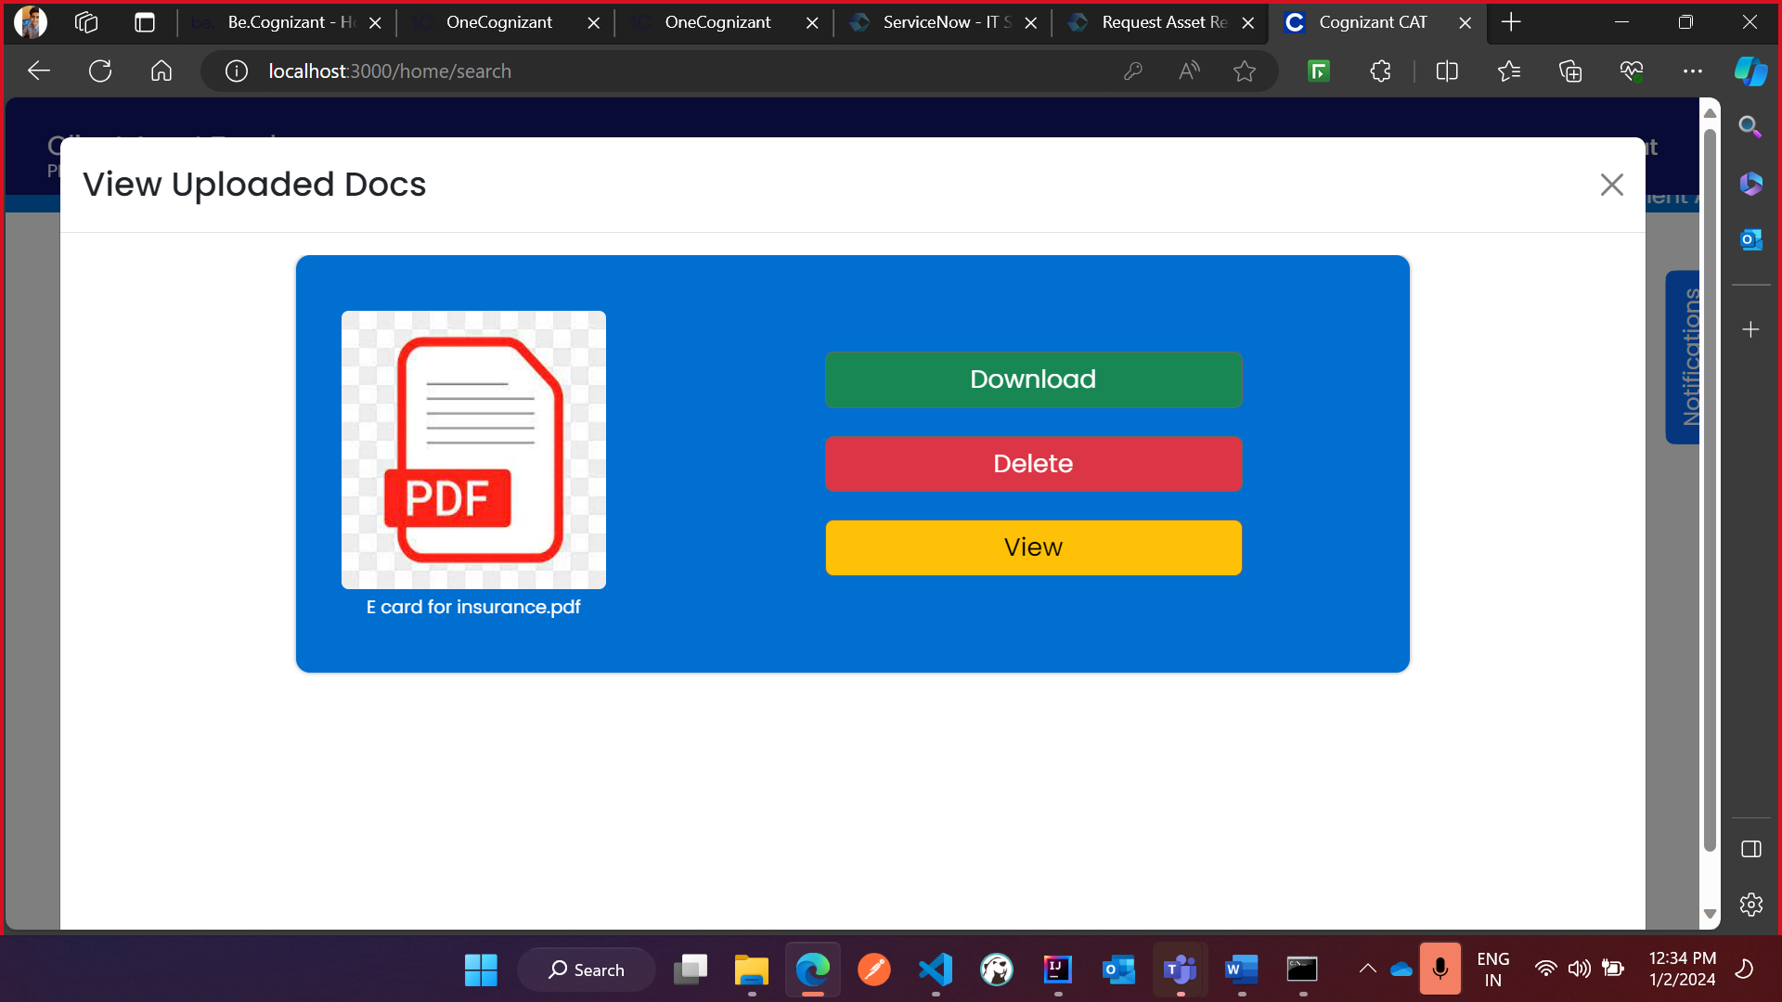

* **Stage 6: Asset Pickup Completed:**
  + Finally, after the user enters the tracking number, DW pickup date and upload DW pickup receipt, the asset changes to asset pickup completed, which is the final step in the asset return.

**Multiple Edit in Home Screen:**

* After loading the employees under the ESA, the user has the option to select multiple employees under the same ESA or other ESA as well. The process is depicted in the images as below:
* Firstly, select the “Select Multiple” option which is present in the top right corner of the table in home page.

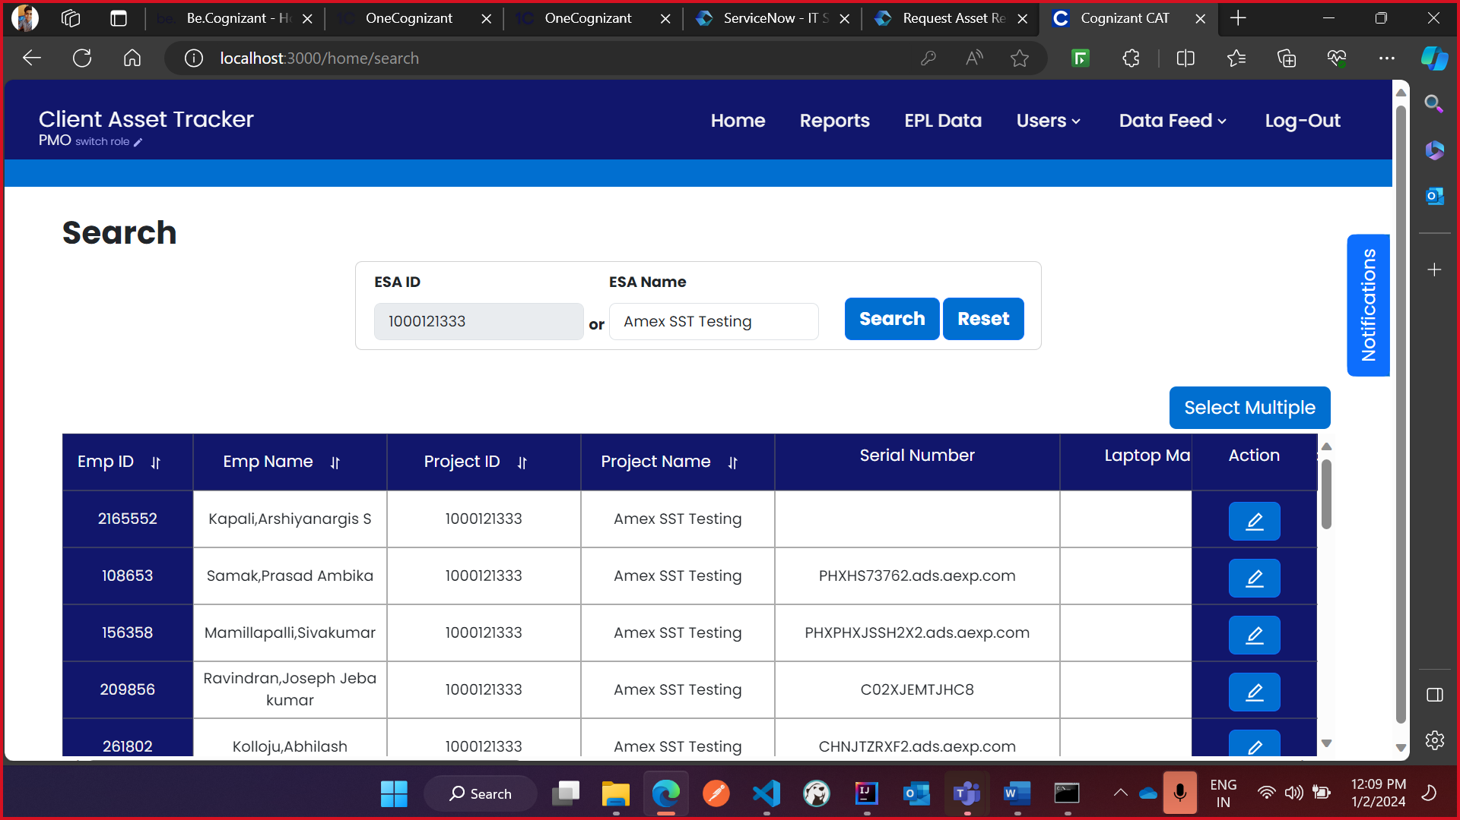

* Then select the records by checking the boxes before the Emp ID column to add the employees that need to be edited at the same time and press on Next button.

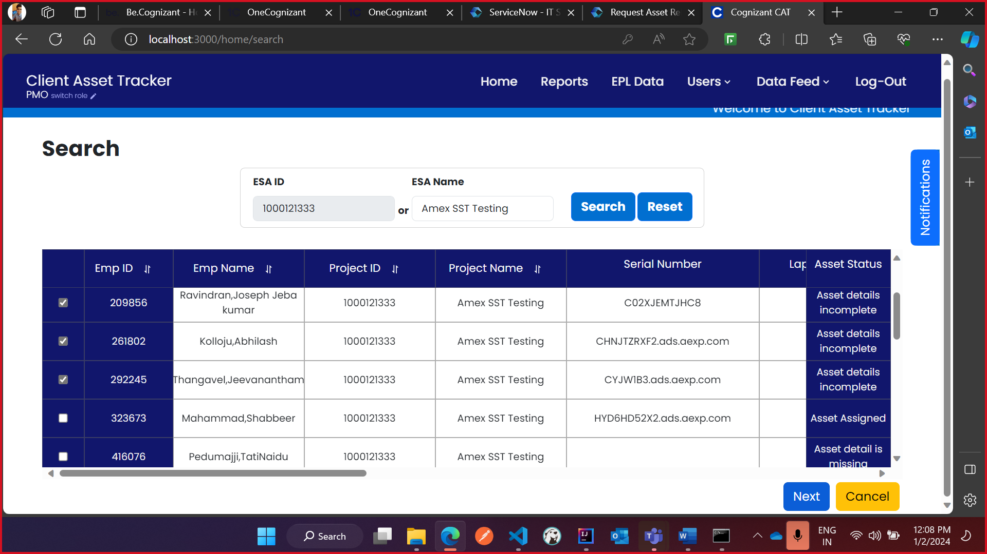

* In the next page, modify the details of the selected employees as required and then press on the green tick under the action column. Only after the user has selected the green tick for all the edited employees, the user should press “Save All” to save all the employees to the database.

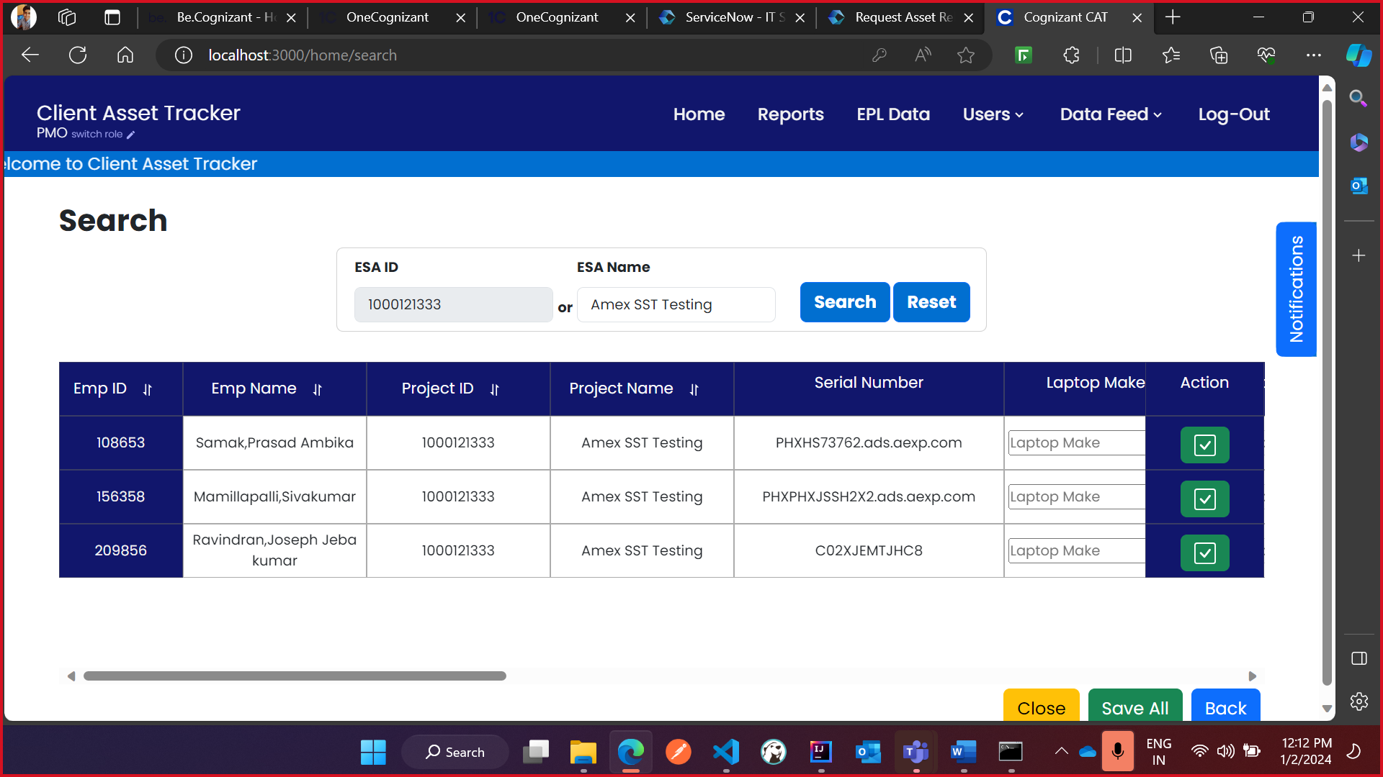

**Note:** In case the associate has multiple assets tagged under them for the same project, the relevant asset can be selected from a drop down menu indicated by an device icon in the “Serial Number” field.

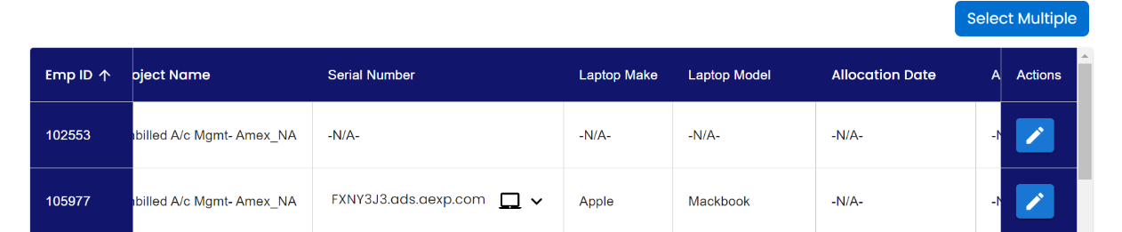

**Master History:**

* The user also has the option to see the past modifications done to an employee’s record in case of any conflict management that may arise by multiple people editing the same record. The master history provides valuable insights that point out the exact details regarding the modifications done to a record with the timestamp, the email id of user who has updated the record, and the fields that have been updated by the user.
* To access the master history of any employee, the user must select the ESA ID or Name and Employee ID or Name from the respective dropdowns.
* Before hitting “Search” button, a third button appears titled “History”, which the user must select to access the history of updates done for the particular employee.

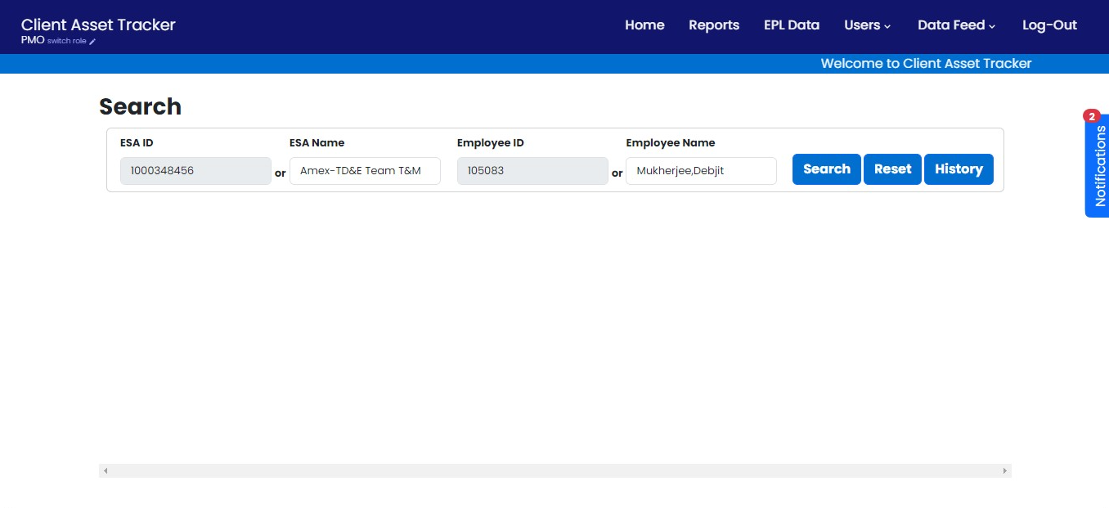

* The below table depicts the history of modifications done for the employee and the number of records represent the number of times the employee’s record has been modified by the user.

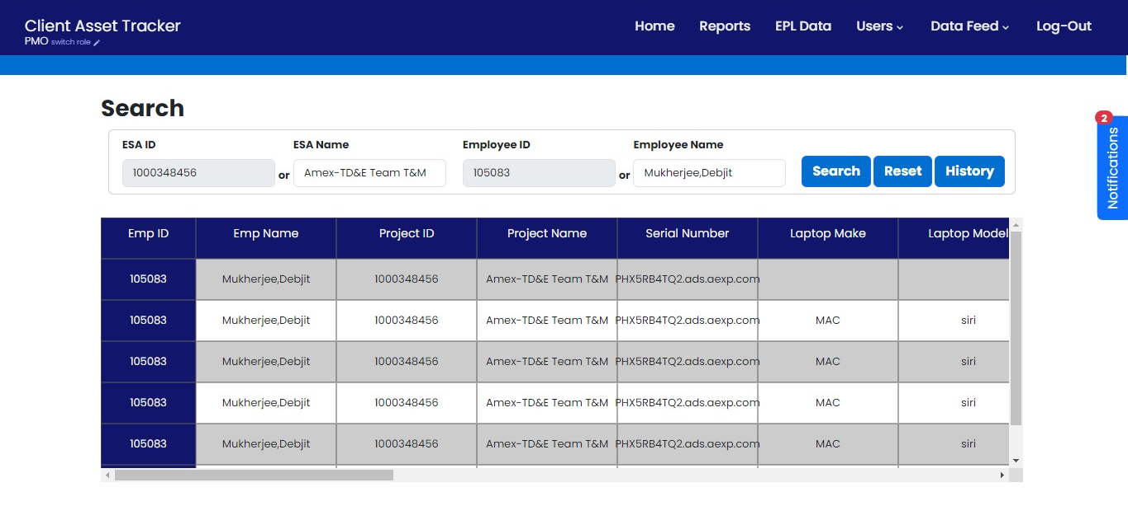

**REPORTS PAGE:**

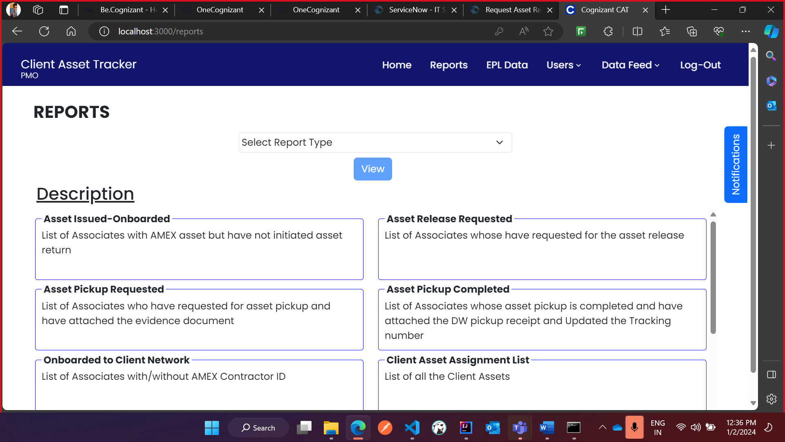

* The reports page contains comprehensive information on employee and asset details in the AMEX account in an organized format which is subdivided into multiple reports that provides an easy way for asset tracking for the organization.
* The main purpose of these reports is to get a list of all the employees that have initiated the asset return and to track which step of the process they are currently in.
* The reports are fetched based on the role of the user, where PMO can view all the records in the database, EPL and ESA PM can view the details of the employees with their respective asset assigned to them.
* The description of all the reports are as follows:
* **Asset Issued-Onboarded**: List of Associates with AMEX asset but have not initiated asset return.
* **Asset Release Requested**: List of Associates whose have requested for the asset release.
* **Asset Pickup Requested**: List of Associates who have requested for asset pickup and have attached the evidence document.
* **Asset Pickup Completed**: List of Associates whose asset pickup is completed and have attached the DW pickup receipt and Updated the Tracking number.
* **Onboarded to Client Network**: List of Associates with/without AMEX Contractor ID
* **Client Asset Assignment List**: List of all the Client Assets
* **Assets Returned Per Month**: List of Associates who have returned their asset in a particular month.
* **Incomplete Associate Asset Details**: List of Associates with incomplete asset details
* **Onboarded to Client Network without Client Asset**: List of Associates with AMEX Contractor ID but don't have AMEX asset.
* **Laptops Returned Per Year**: List of Associates who have returned their asset in a particular year.

**Steps to view and download a Report.**

* Go to the reports page and select a report from the dropdown menu and press on View.

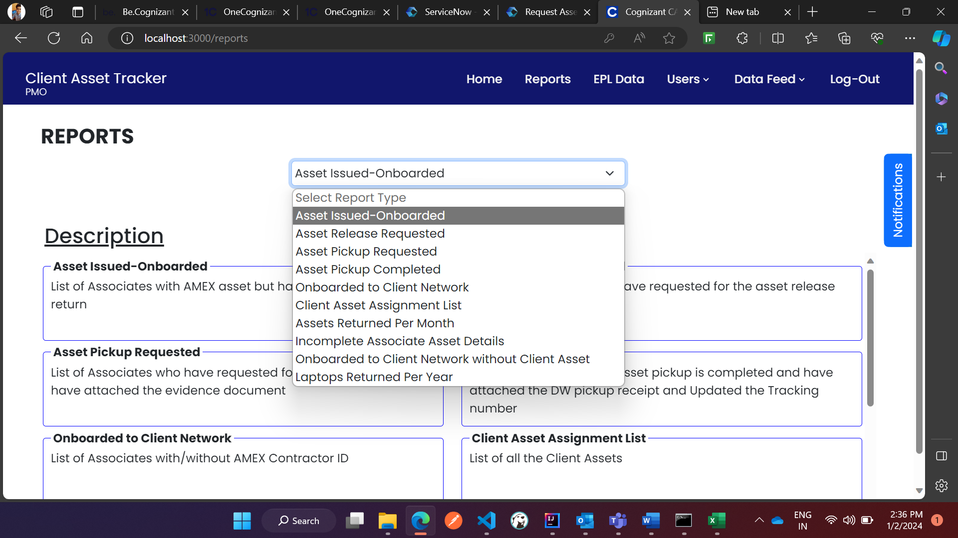

* After selecting the report, the user would see the page loaded with data with pre-selected columns that has been assigned for each report.

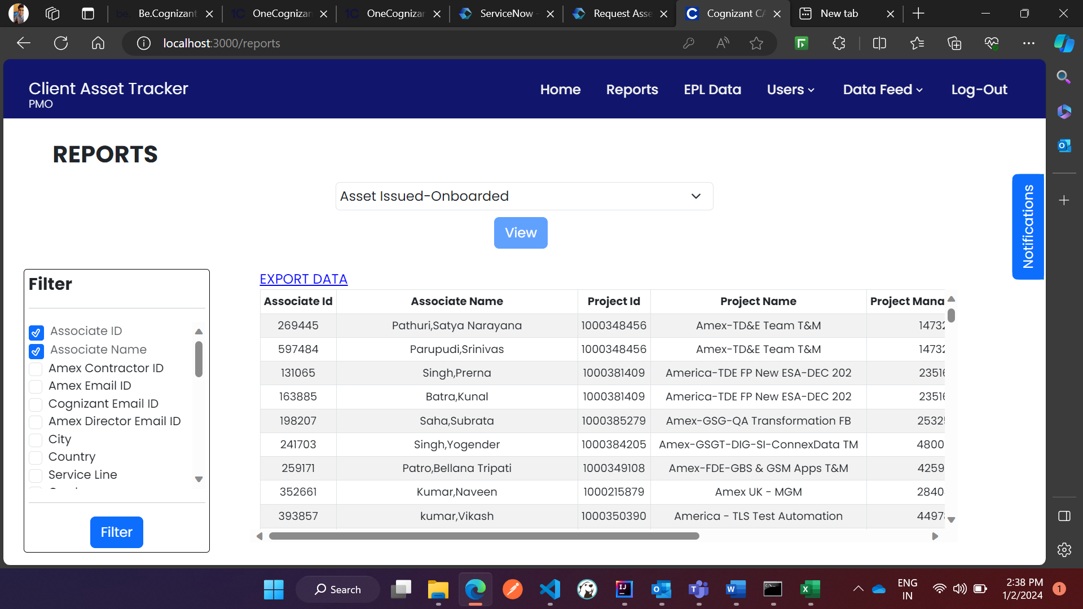

* If the selected report is empty, a pop up would indicate that the selected report is empty and has no fields to display.

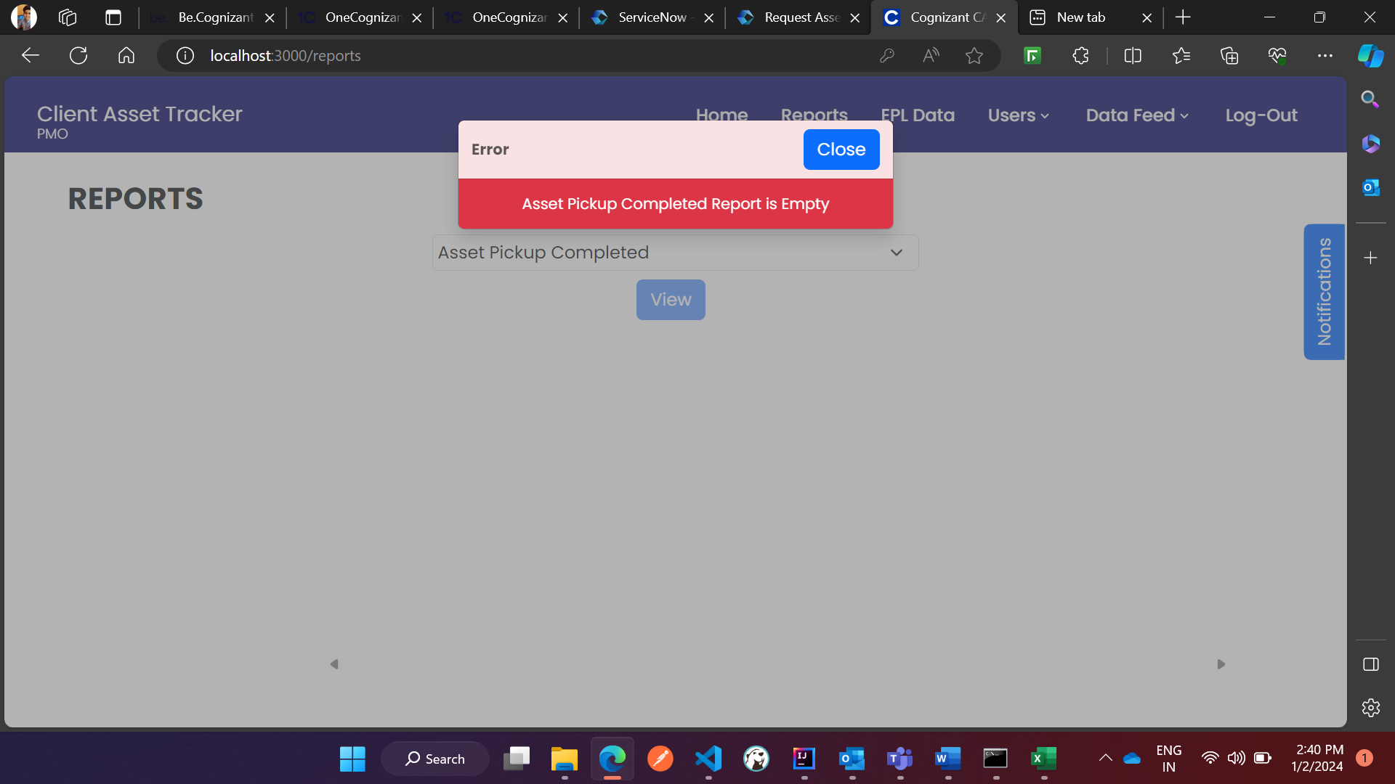

* The user has the option to filter the displayed columns for a report having data and that can be selected from the Filter tab, present in the left of the table, where the user can use the checkboxes to select the desired columns needed for the report and press on “Filter” button again to alter the report.

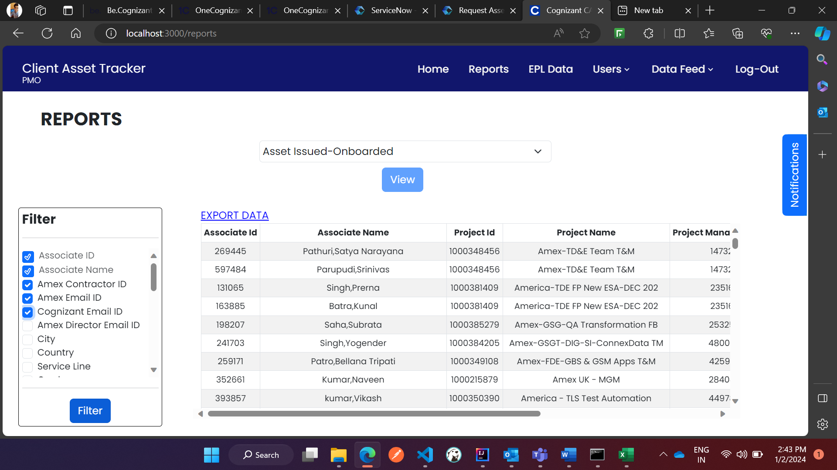

* The user would be presented with a new report with additional columns selected in the filter tab.

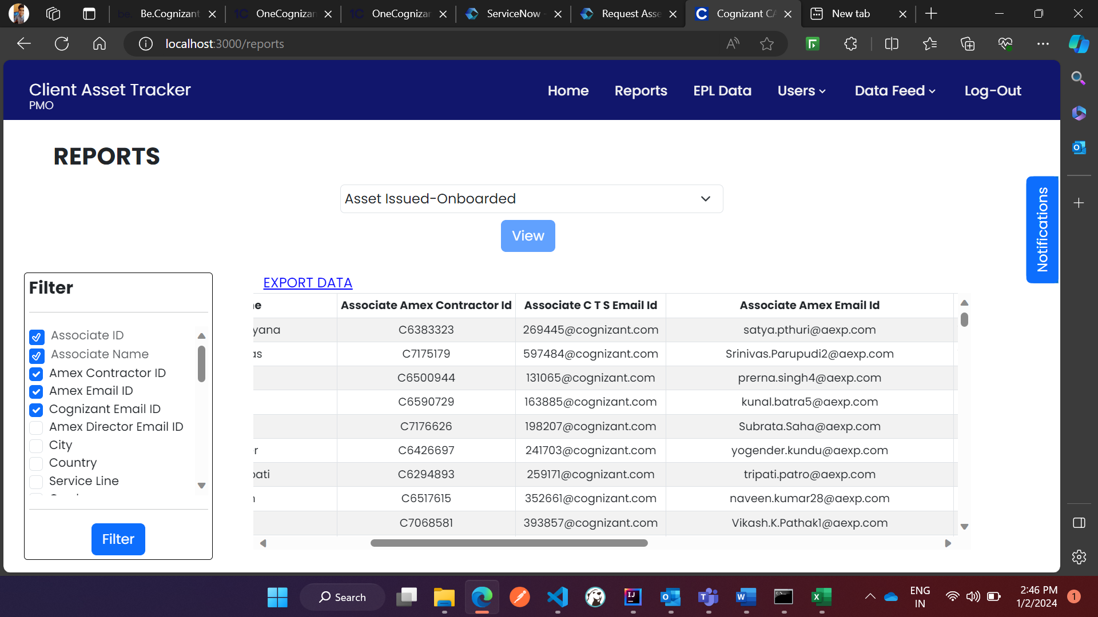

* The user can download the generated report by clicking “EXPORT DATA” present in the top left corner of the report which opens a new pop up, asking the user to download the report in an excel or pdf format.

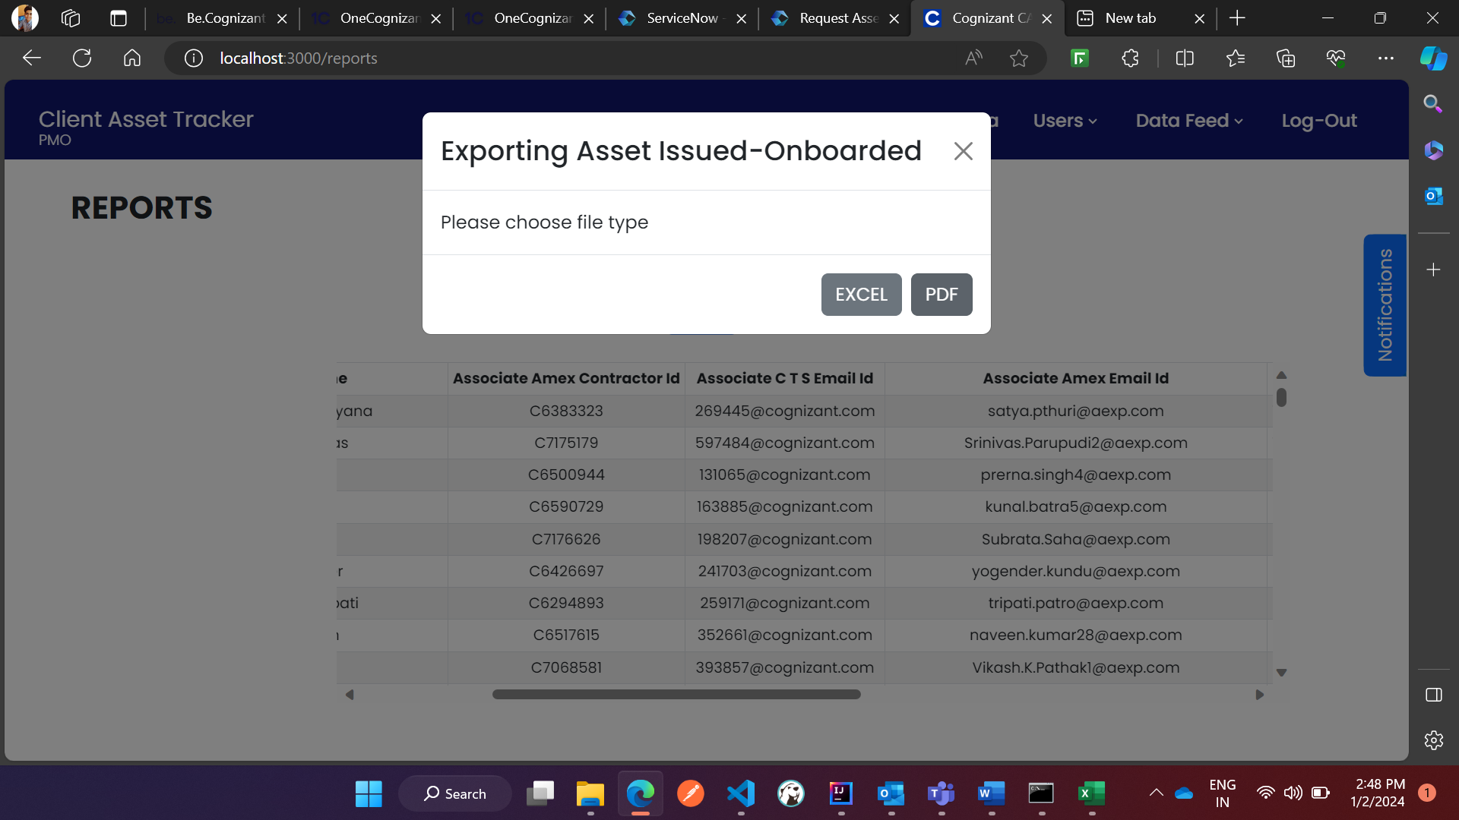

* The user can now download the report in excel or pdf format in their local storage and would look as depicted in the images below:

**PDF Report**

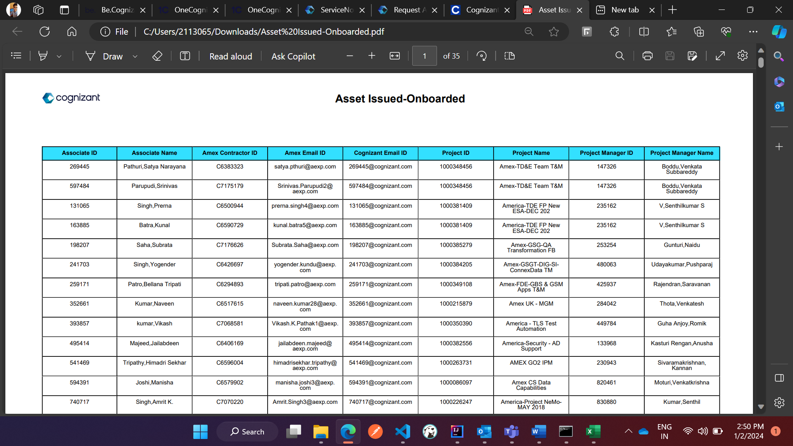

**EXCEL Report**

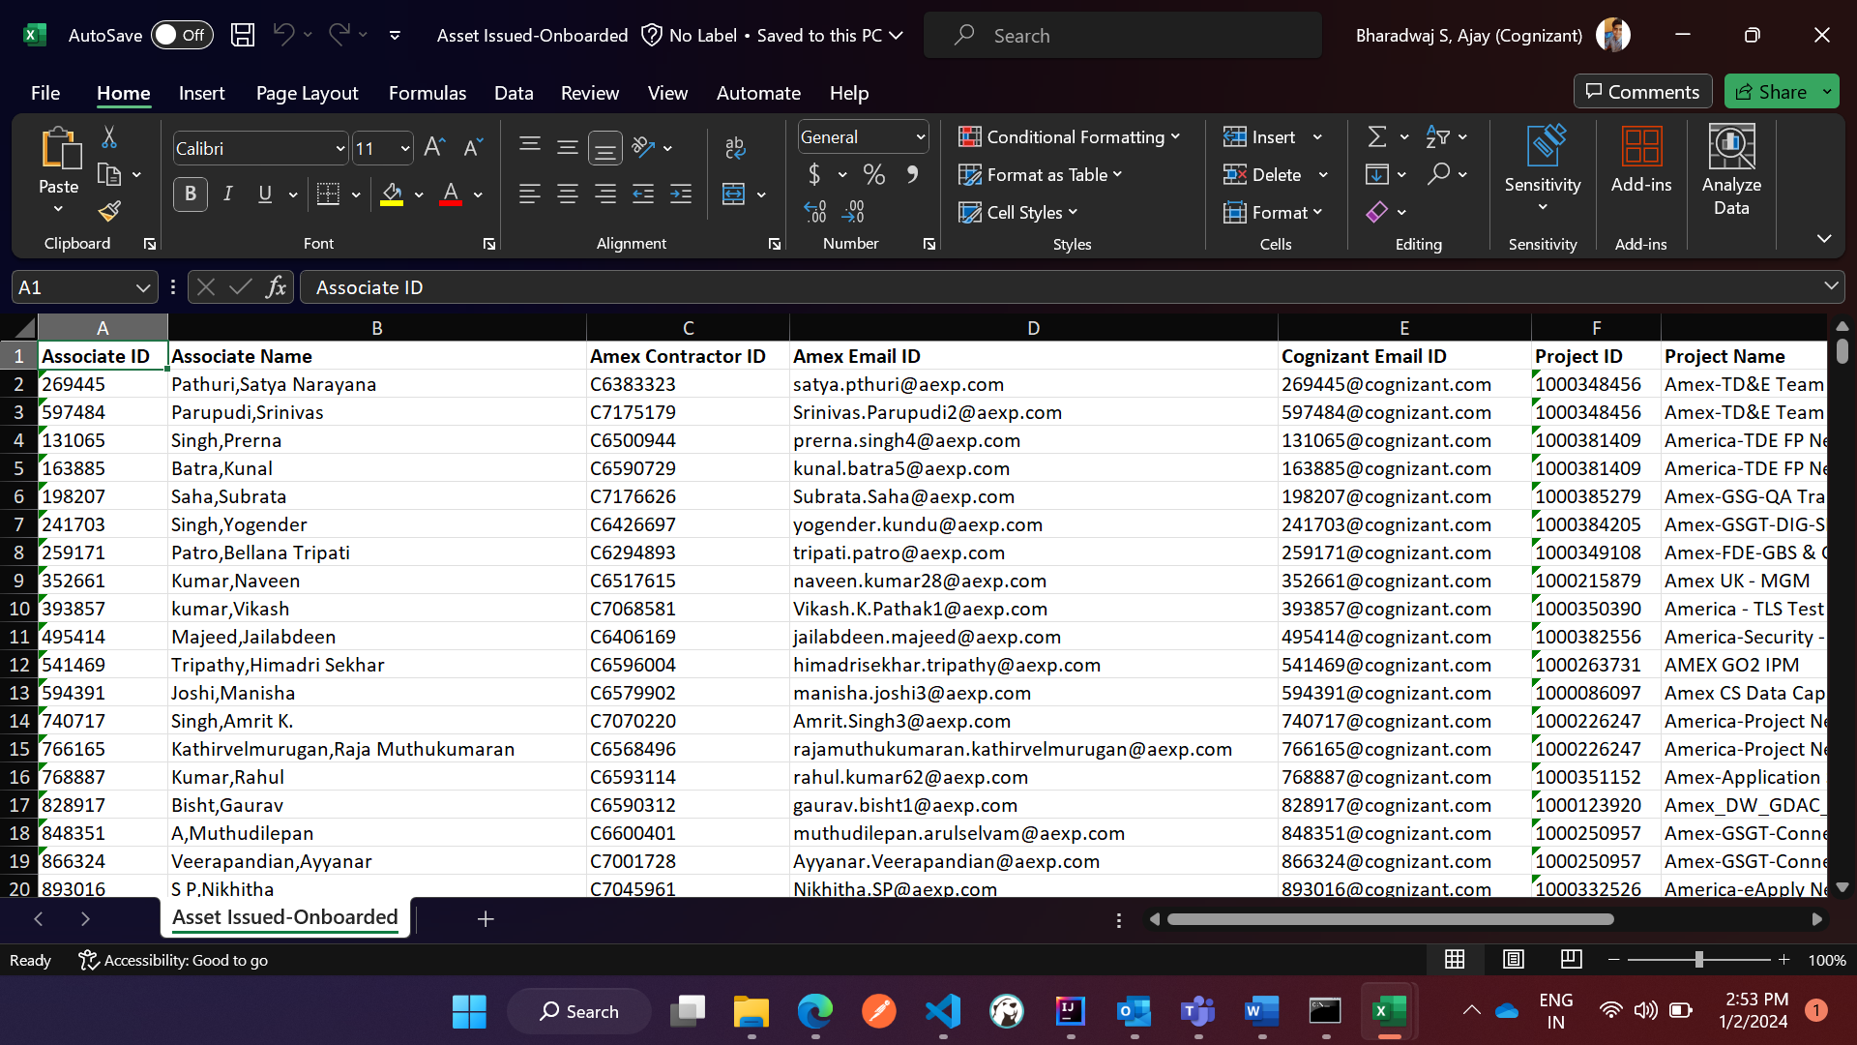

* **Note:** If an associate has more than one asset in the same ESA, then their record would be displayed with yellow background in both reports page and downloaded files.

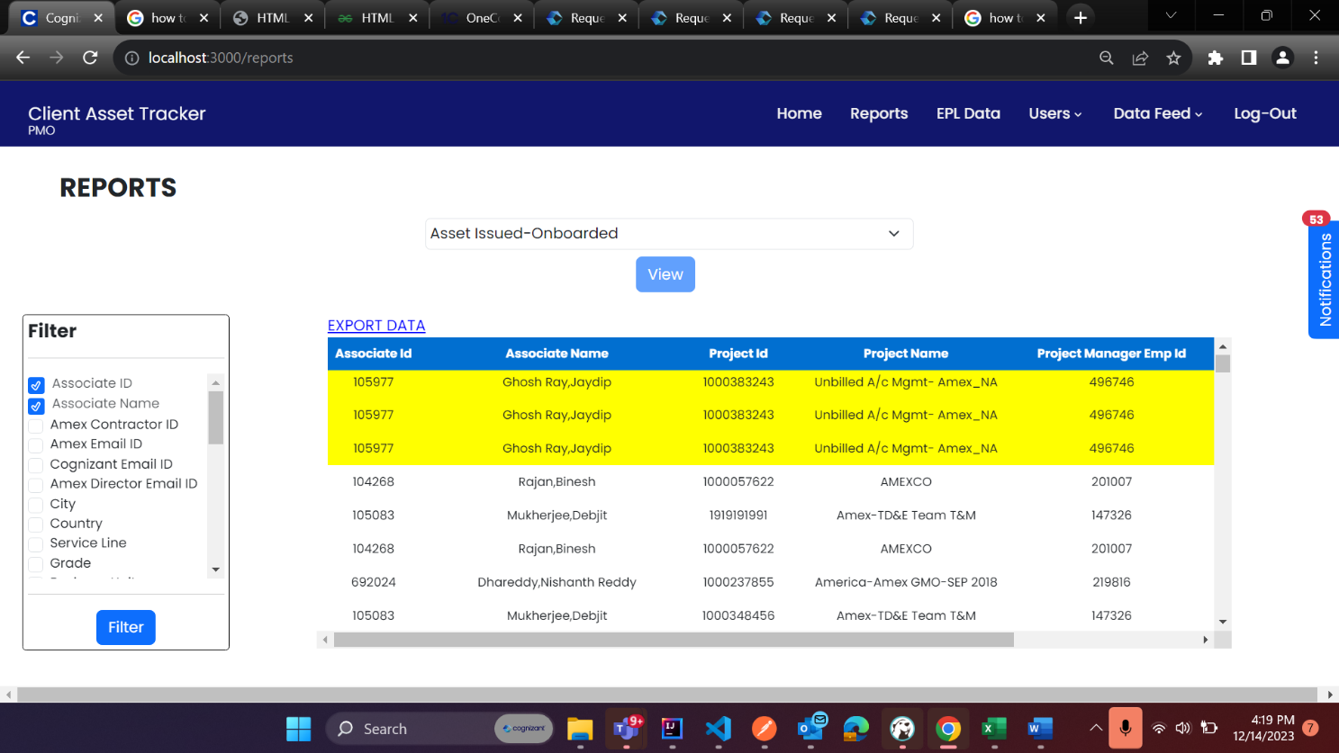

**NOTIFICATIONS:**

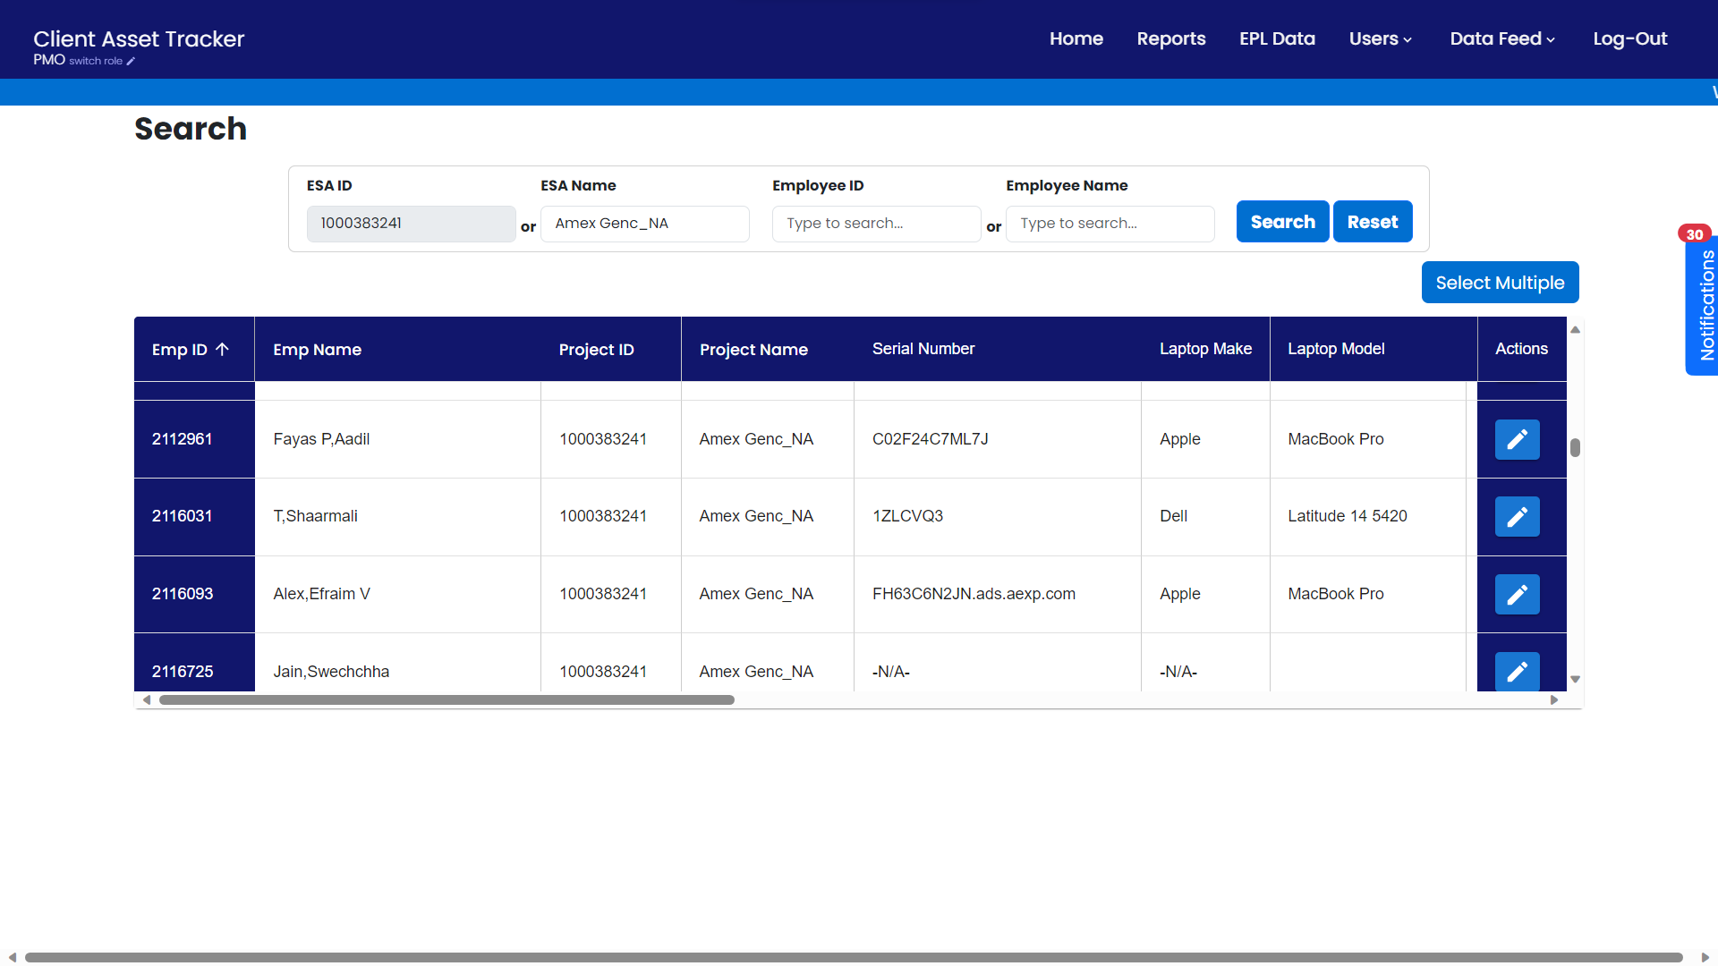

* The notifications tab on the right-hand side of the application is a feature to notify users real time about the updates within the Client Asset Tracker application.
* A user would get notification’s depending on their role within the application.
* The number of unread notifications can be easily glanced on top of the tab.
* Interacting with the notification tab would expand it, to the give the user a detailed view of their pending notifications.

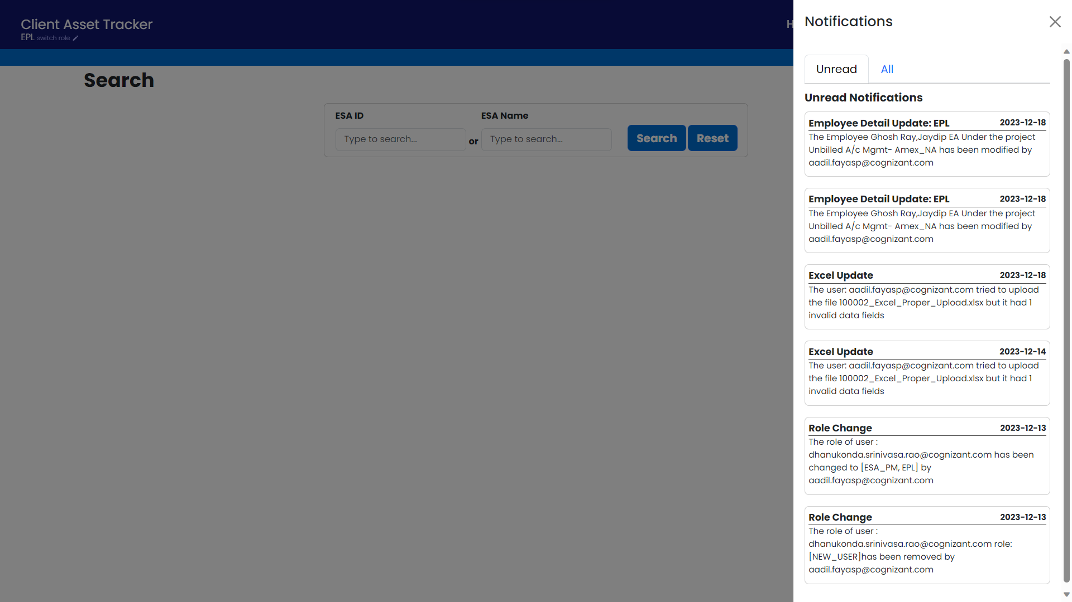

* From here, the user has options to address the notifications by interacting with the relevant notification as well as access all their previously addressed notification.

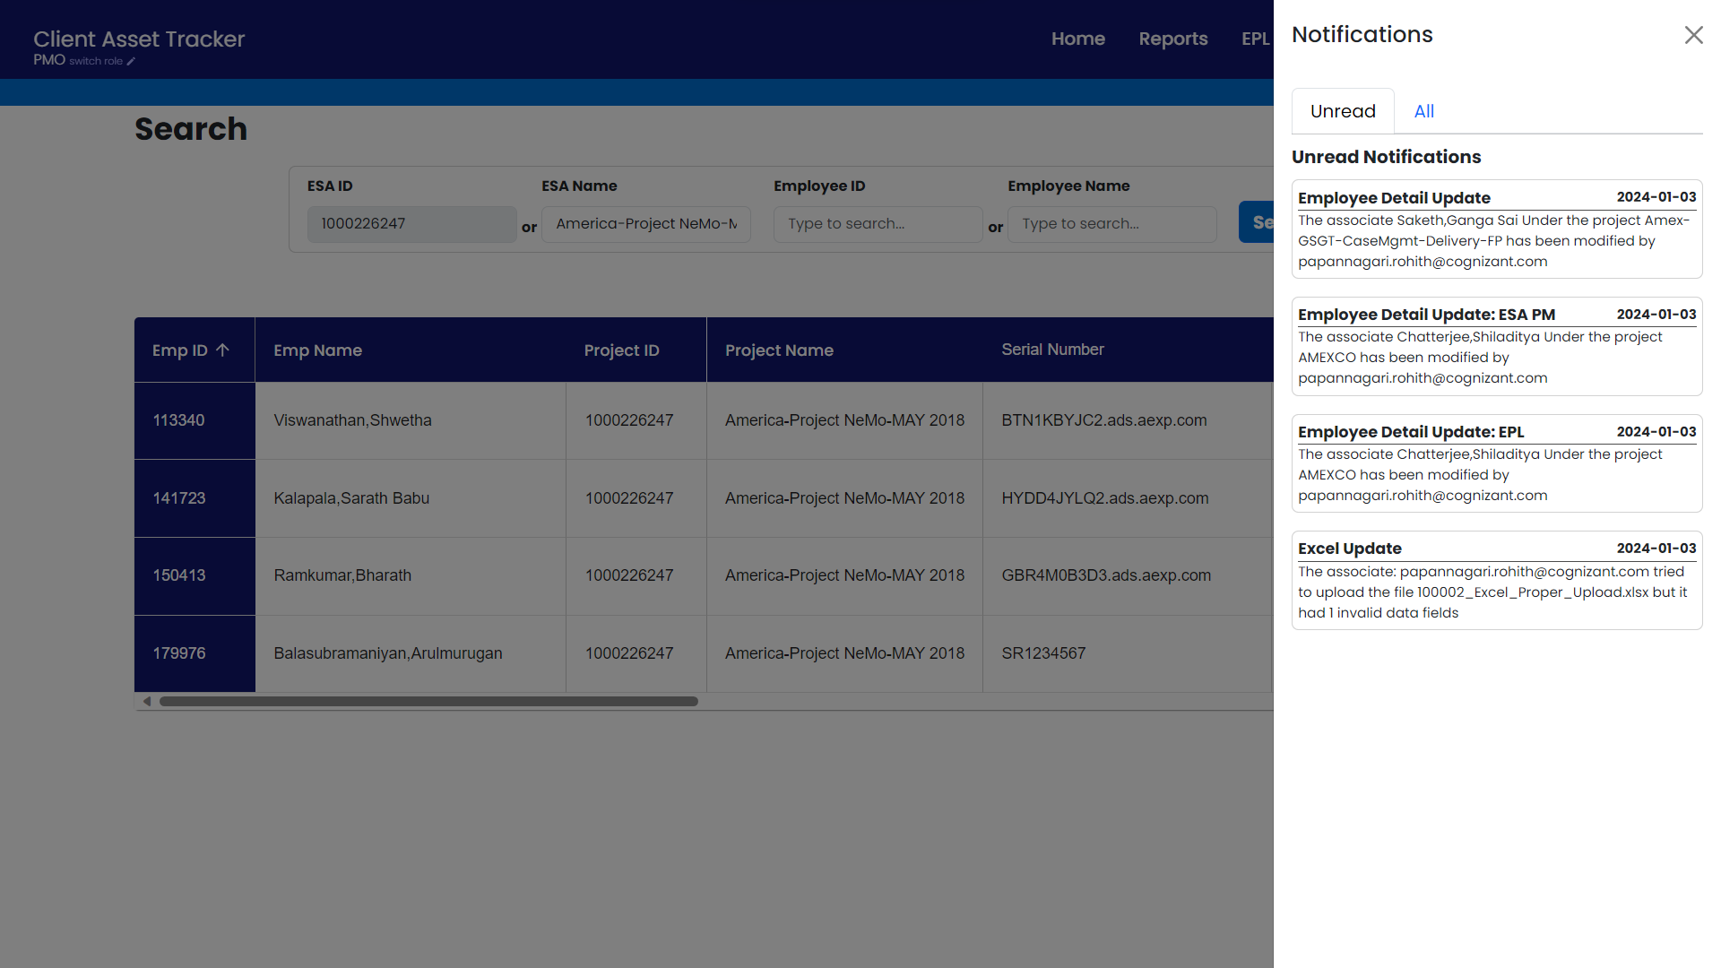

* The “All” notifications tab showcases both the addressed notification as well as unaddressed notification.

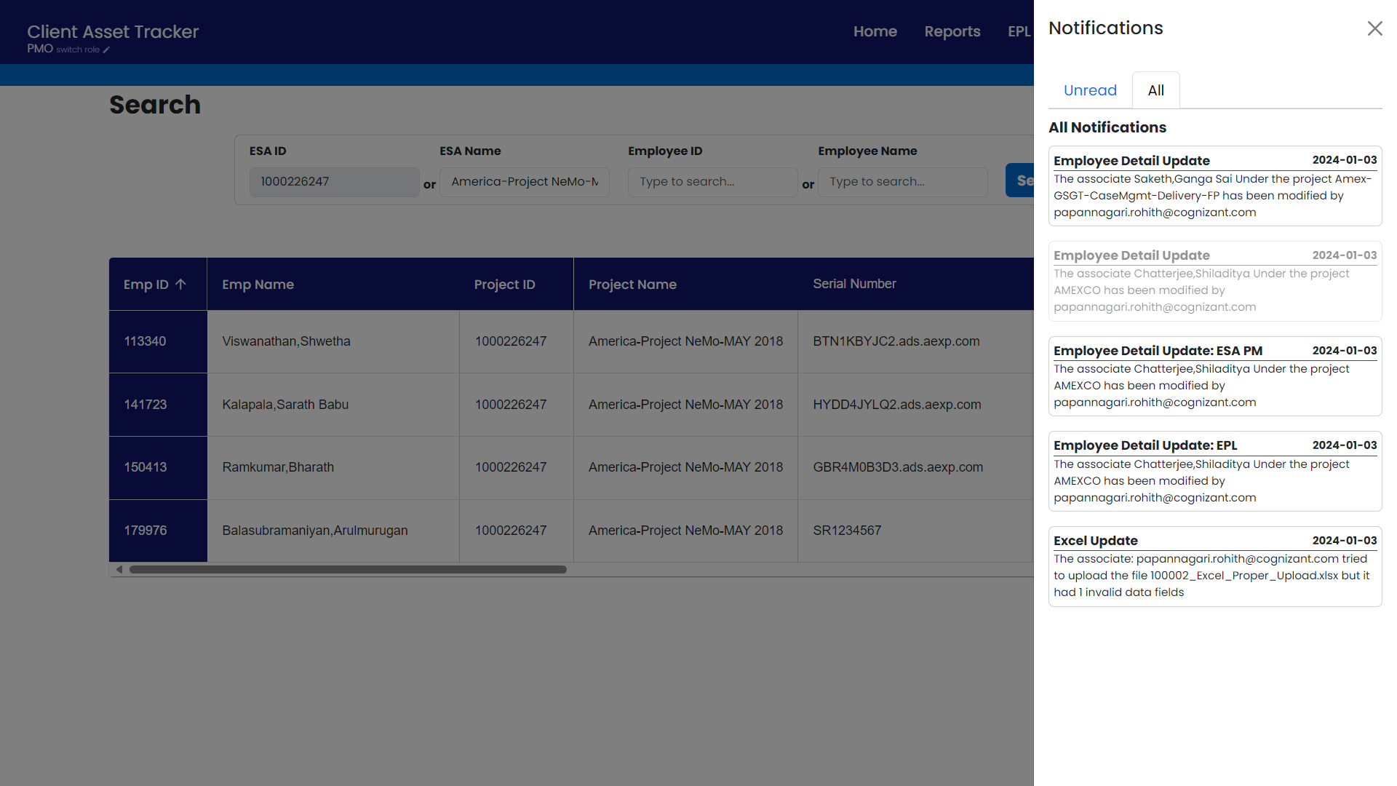

* Depending upon the role of the user, the notification’s they would receive differs upon the scenario.

**Types of Notifications:**

* The Following table contains each scenario, and the roles which would be notified.

|  |  |  |  |  |  |  |
| --- | --- | --- | --- | --- | --- | --- |
| Notification Scenario | Description | Current User | PMO | EPL | ESA PM | Notes |
| **Excel Upload: Success** | A successful updation of associate records with the data feed feature | Y | Y | Y | Y |  |
| **Excel Upload: Updated Records** | Associate Records have been updated with an Excel File | N | Y | Y | Y | All PMO's, and related EPL & ESA PM to the associate would be notified |
| **Excel Upload: Missing Field & Invalid Data** | An incomplete updation of associate records with the data feed feature | Y | Y | Y | Y |  |
| **Home Page: Associate Data Update** | Updation of an associate's asset details from the home page | N | Y | Y | Y | All PMO's, and related EPL & ESA PM to the associate would be notified |
| **EPL: Add or remove** | Addition or Removal of a new EPL | N | Y | Y | Y |  |
| **User: Change Role** | A User's role has been changed | N | N | N | N | Only the affected user would be notified |